AWS Cloud Quest  
**Task 7. Connecting VPCs**  
Allow communication between applications hosted in different VPCs by using VPC peering. The marketing and development EC2 instances need to access the financial services server in the finance department’s VPC.

|  |  |
| --- | --- |
| Person | Hi I’m the city’s chief marketing officer. Thanks so much for coming as soon as you did. |
| Me | It’s my pleasure. How can I be of service? |
| Person | We wanted logical isolation of our applications, so we set up separate virtual private cloud for our marketing, development, and finance departments. However, all departments depend on getting reports from Finance.  Due to the isolated VPCs, the team members in marketing and development need to raise tickets to gain access to finance reports, which reduces our productivity. Any Ideas on how we can improve this? |
| Me | Amazon VPC offers a feature called VPC peering. After you create a peering connection between two VPCs, you can route traffic between the VPCs by using private IP addresses. |
| Person | That sounds great. Can I peer one VPC to multiple VPCs? |
| Me | Yes, you can, but peering connections are not transitive. This means that if you create peering connections from marketing to finance and development to finance, no traffic is allowed between marketing and development unless you create another peering connection between them.  You can also peer with VPCs in different accounts. Are you using different accounts for your VPCs? |
| Person | No. We currently aren’t using different accounts.  Okay, that’s good to know. VPC peering supports peering between multiple accounts, in case we add new accounts later.  Great! Can you help us improve access to our finance workloads! |
| Me | Accepted! |
| Person | Thanks! I can’t wait to get the financial data that we need. |

**Learning Objectives**

* Configure VPC peering between the marketing and finance networks.

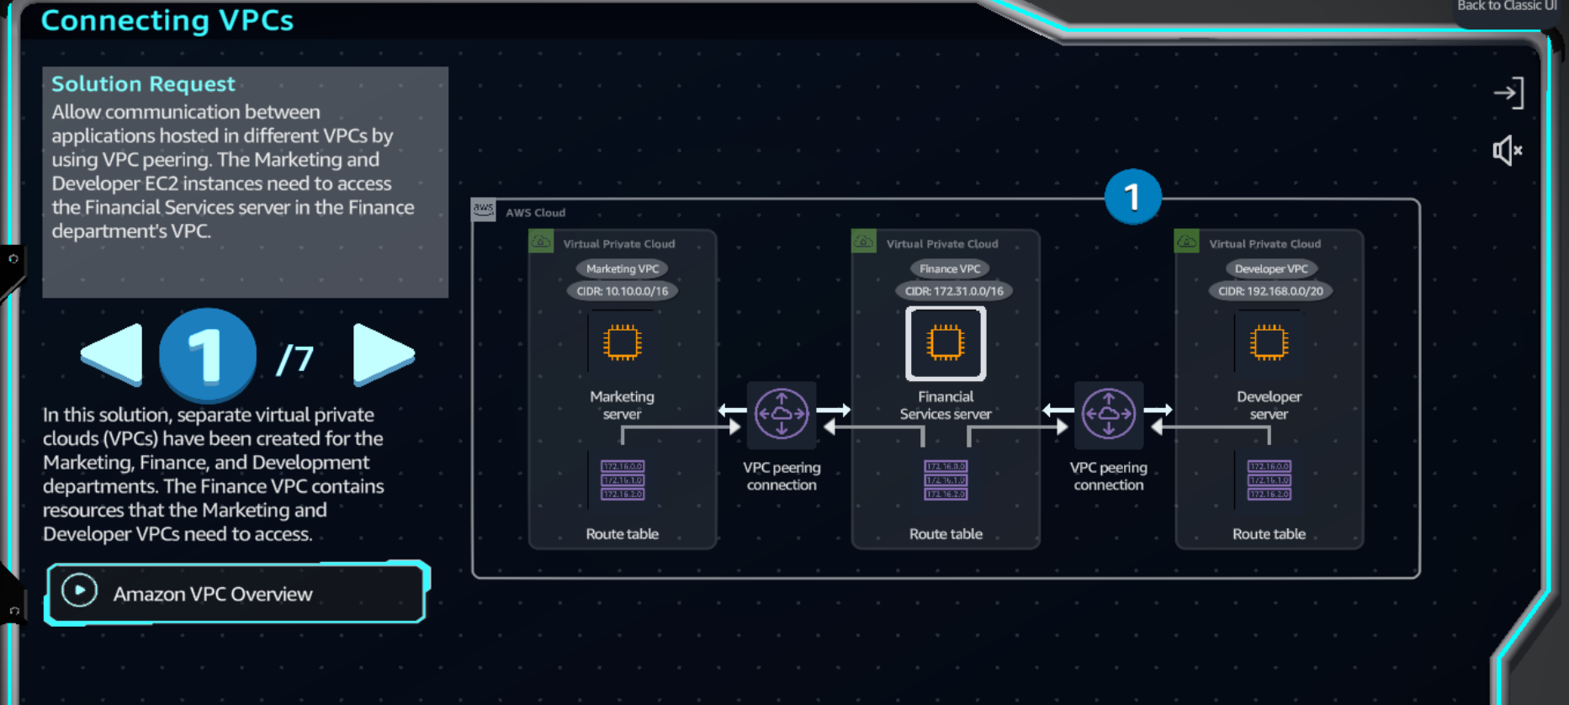

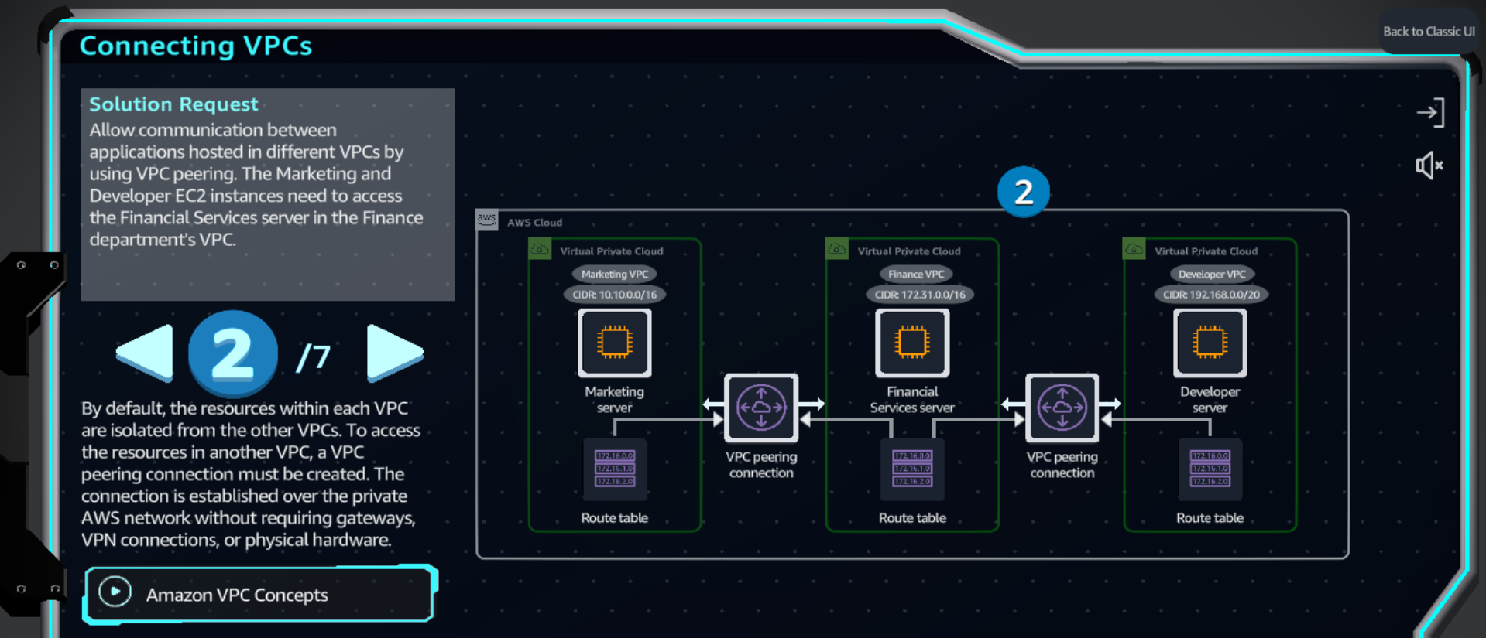

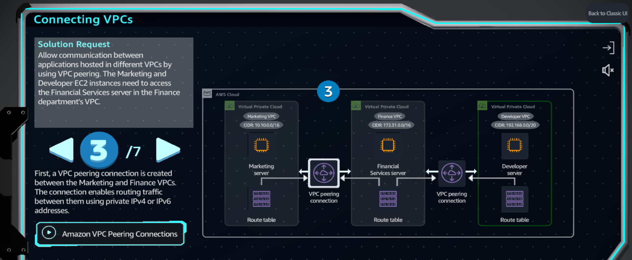

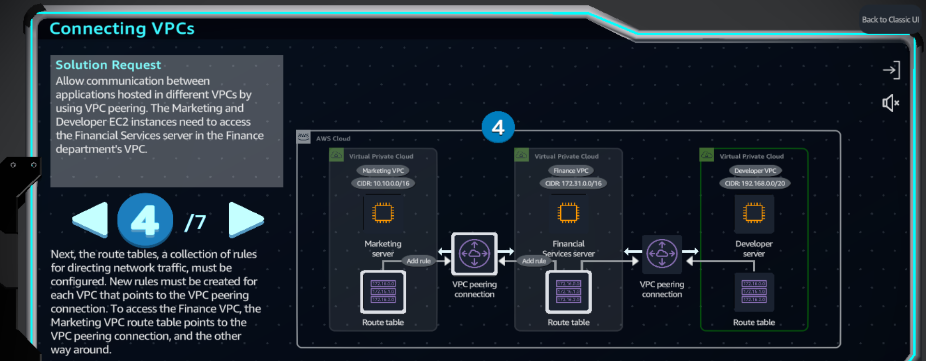

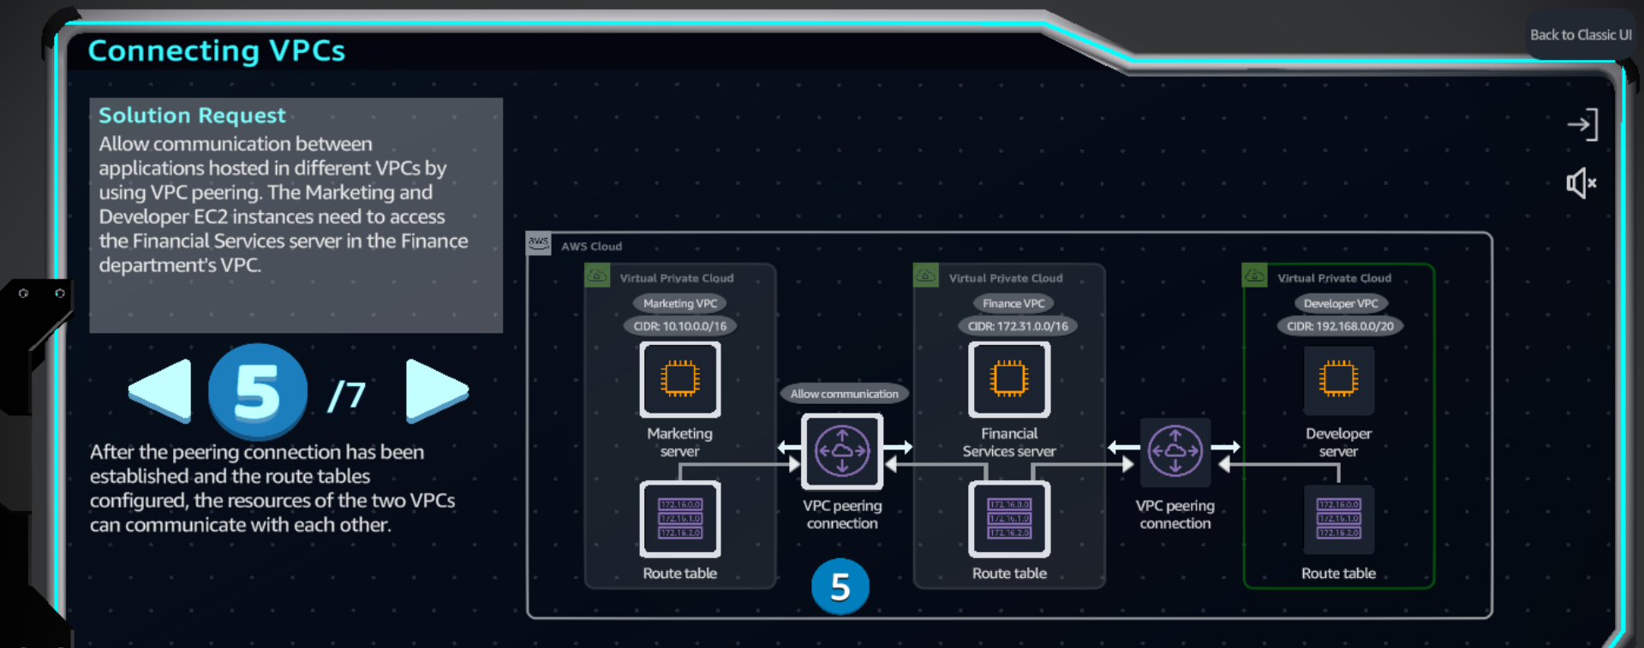

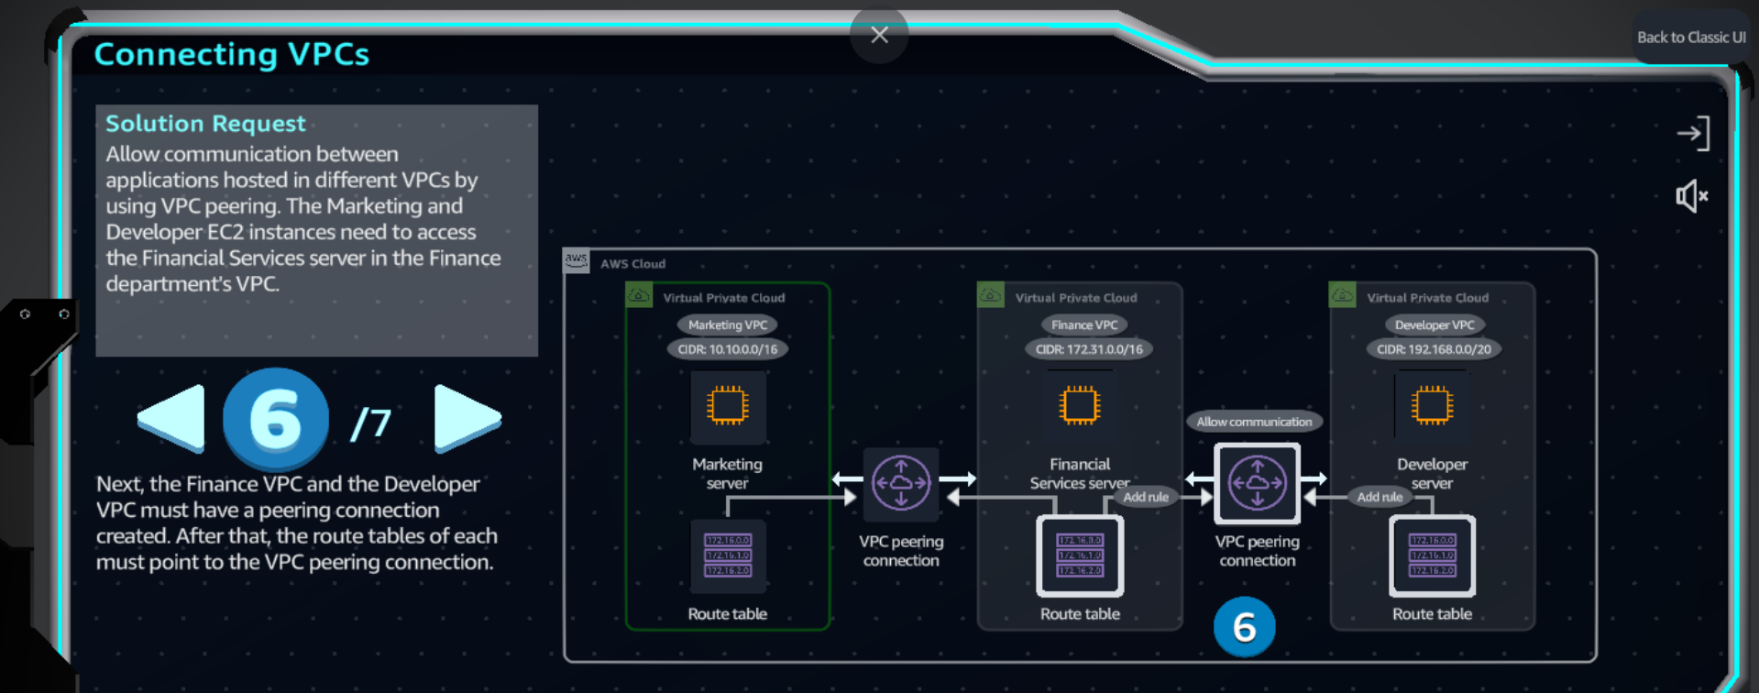

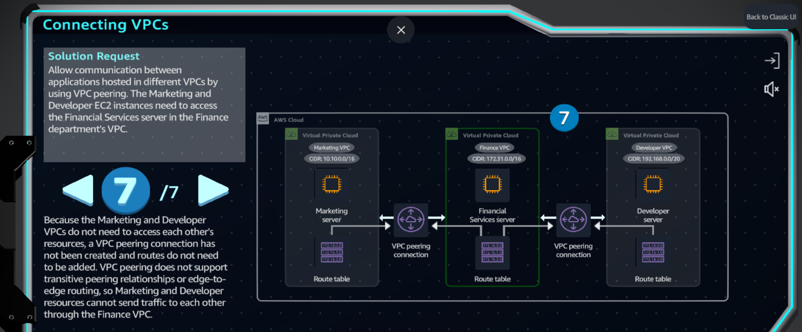

**Practice Lab**

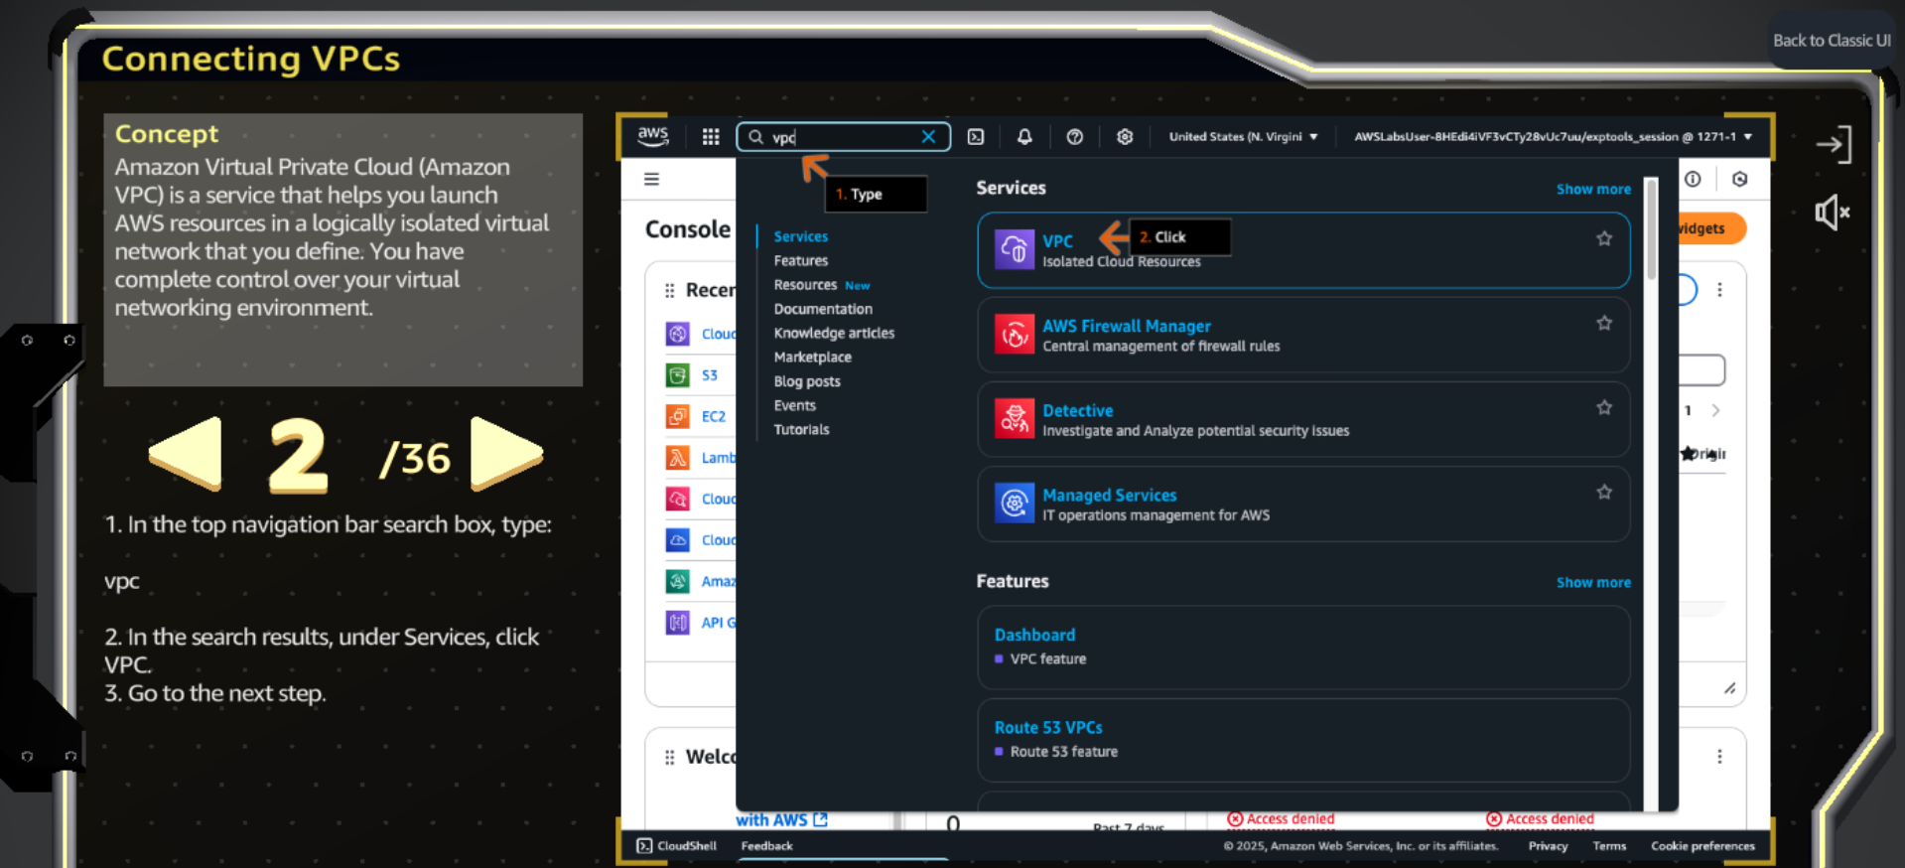

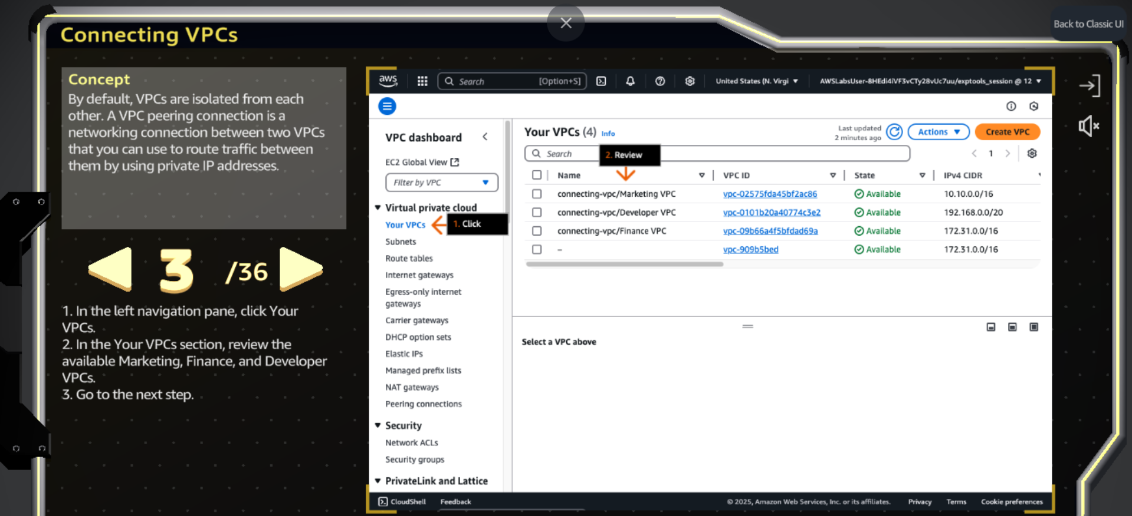

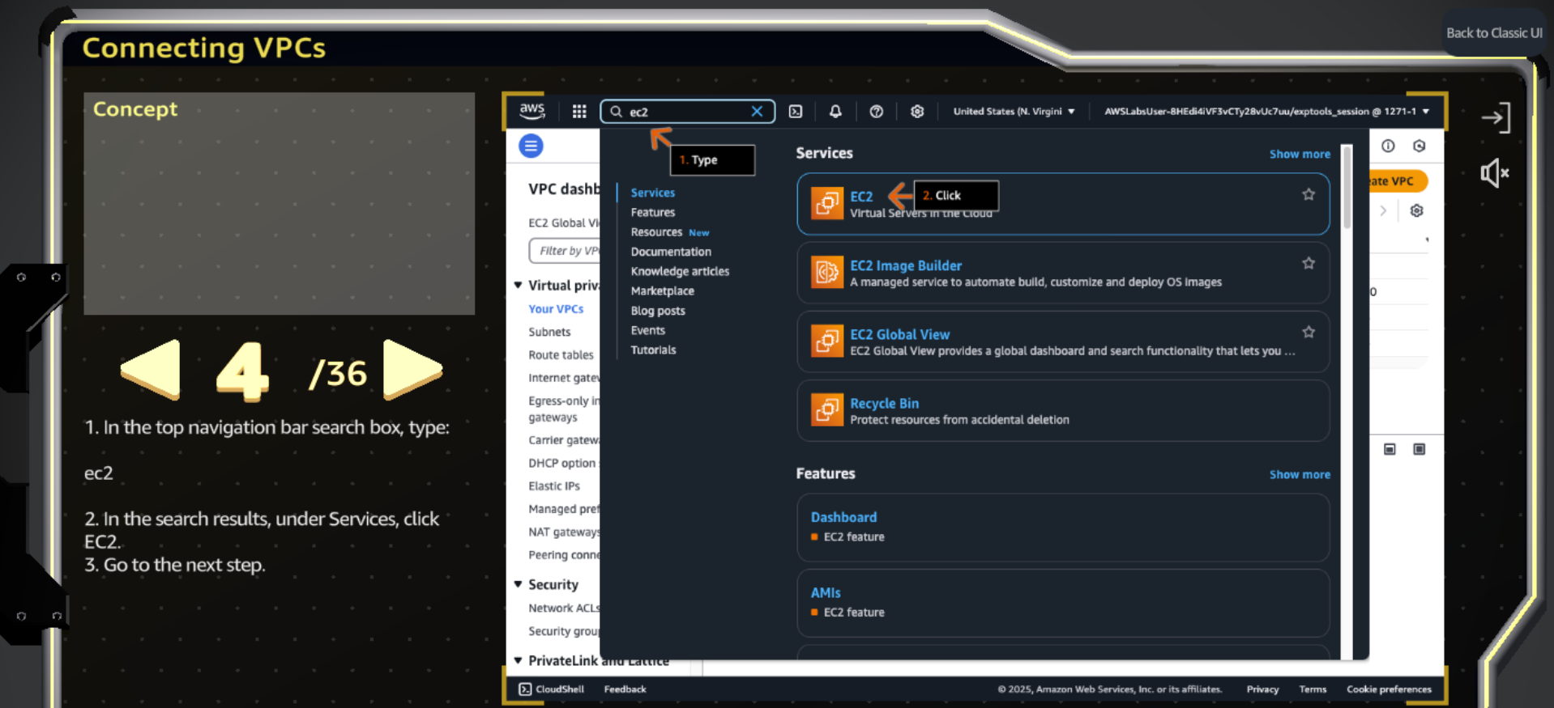

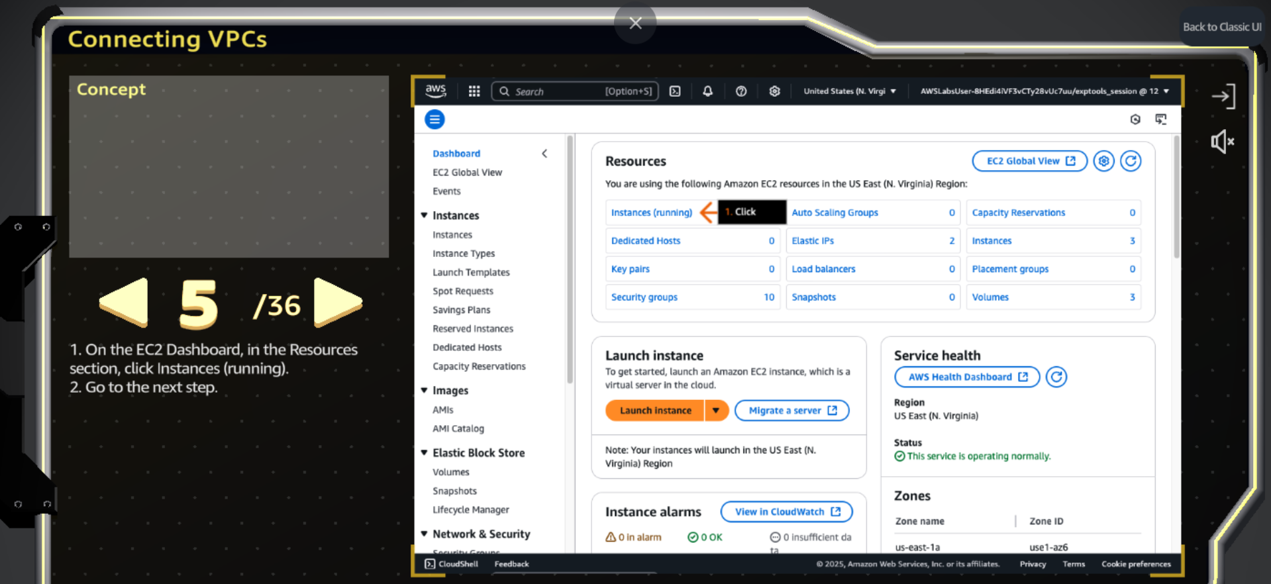

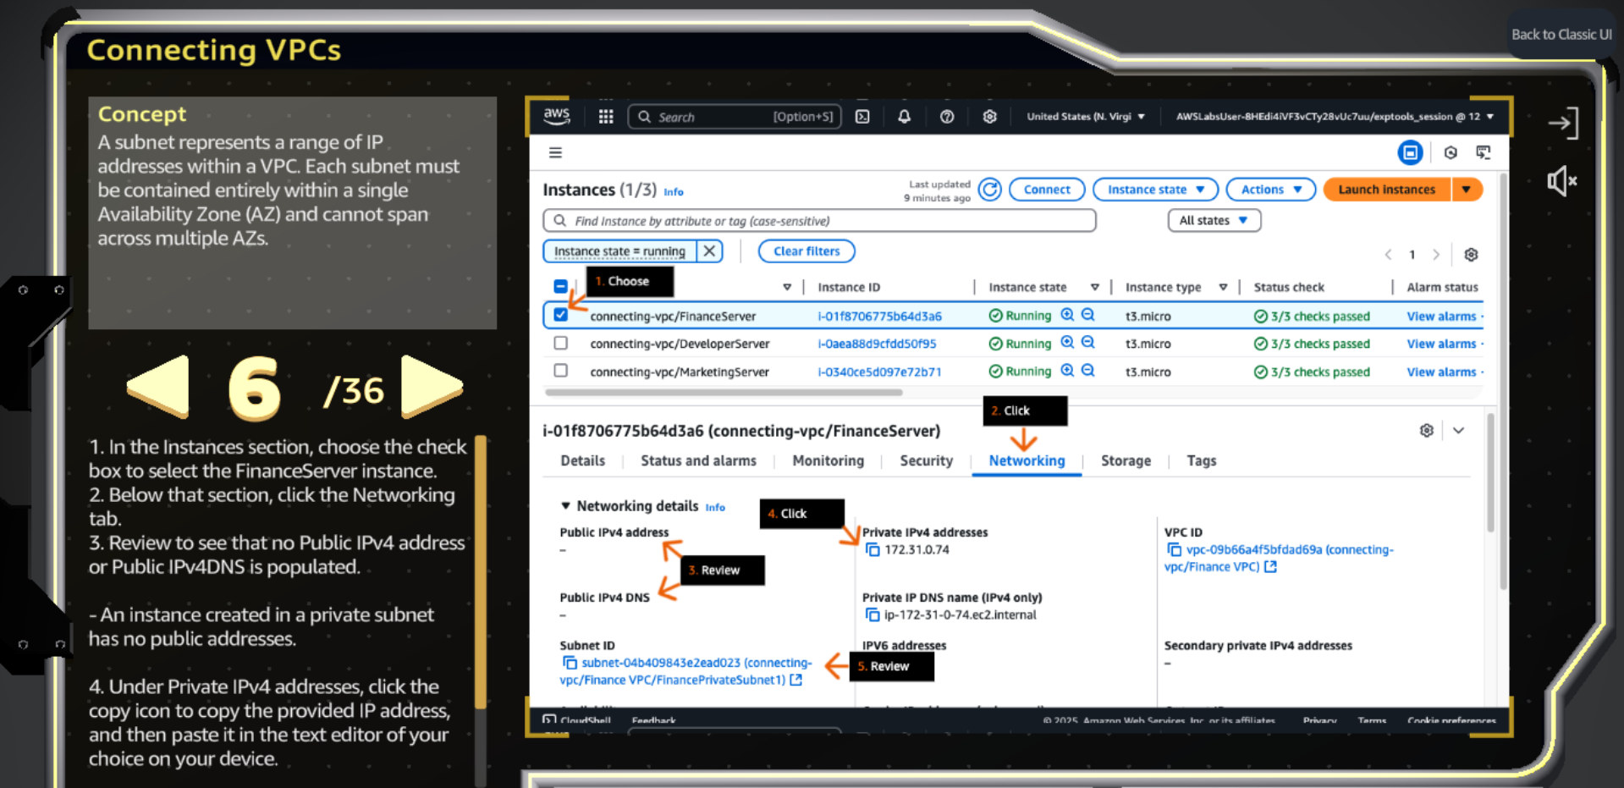

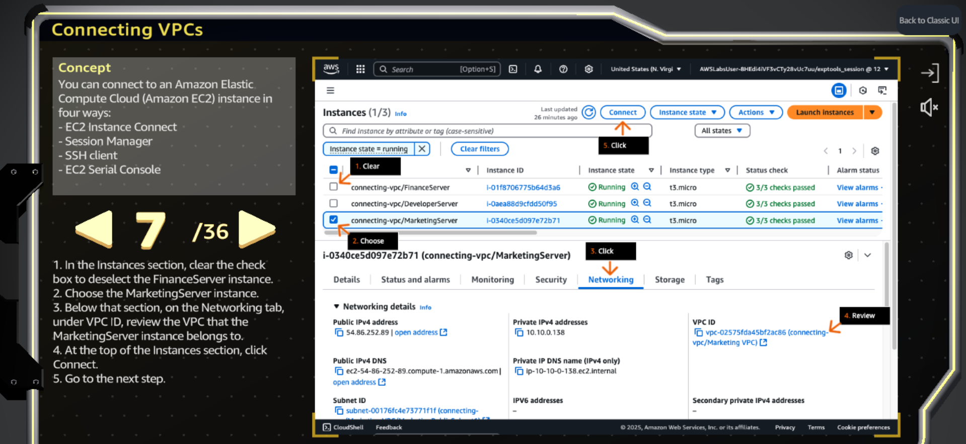

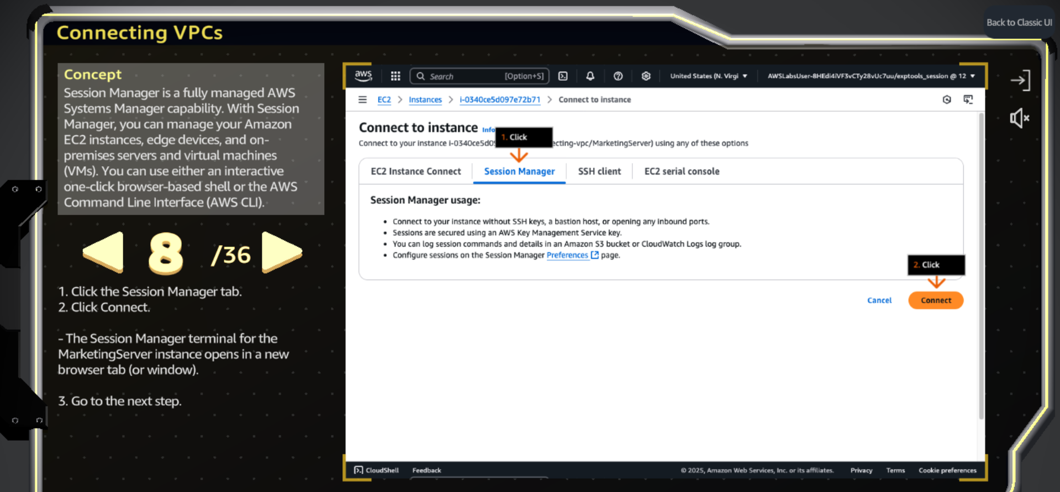

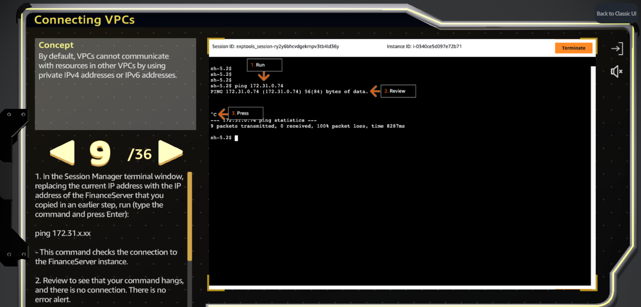

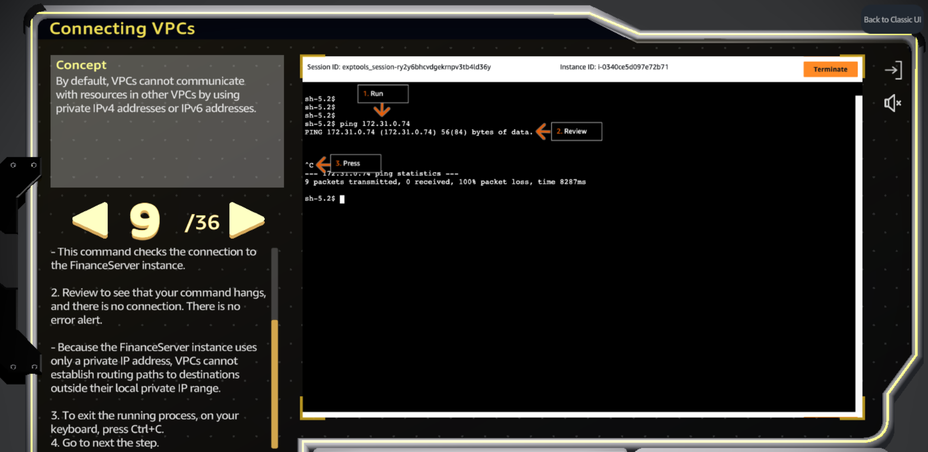

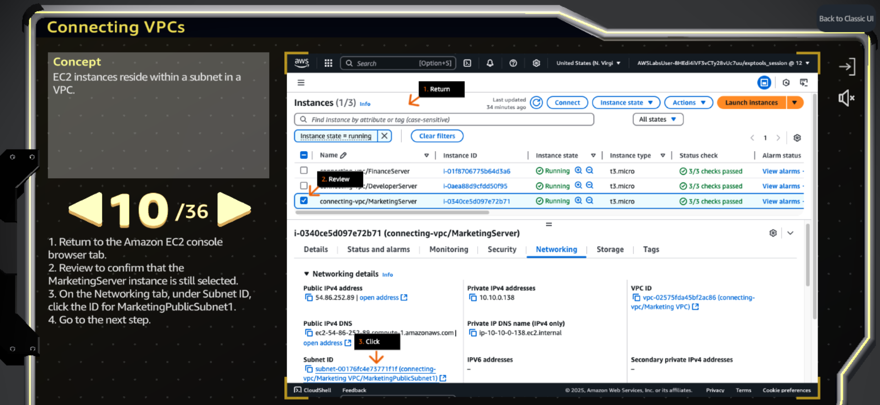

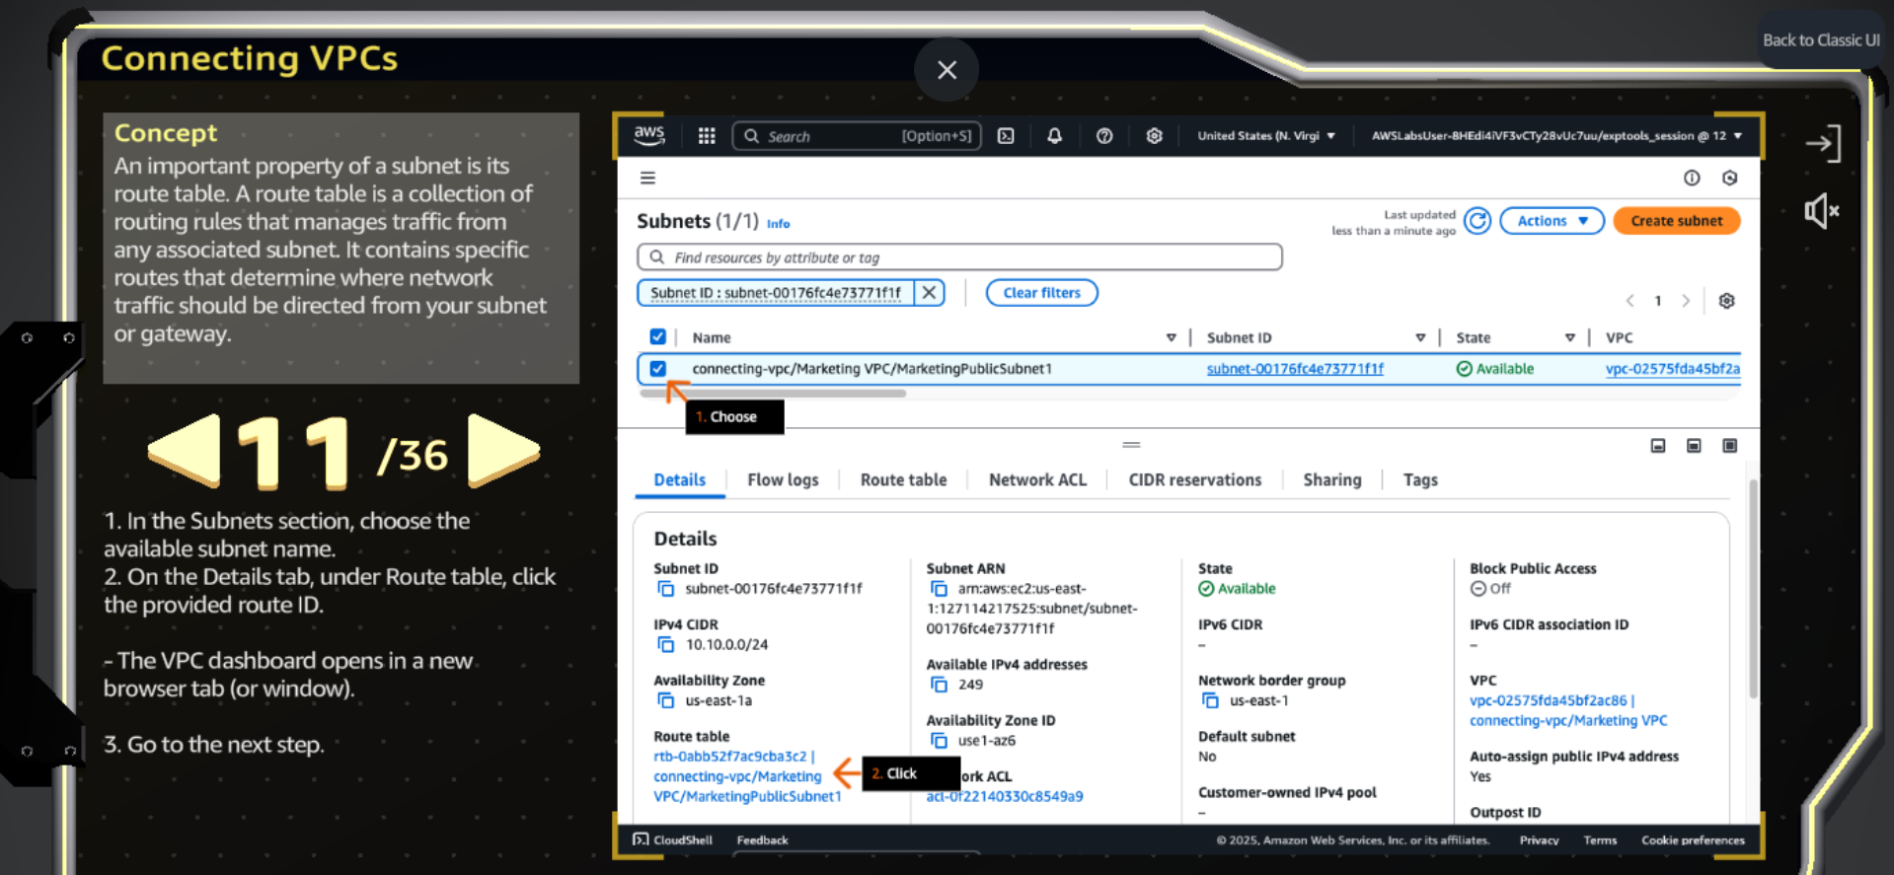

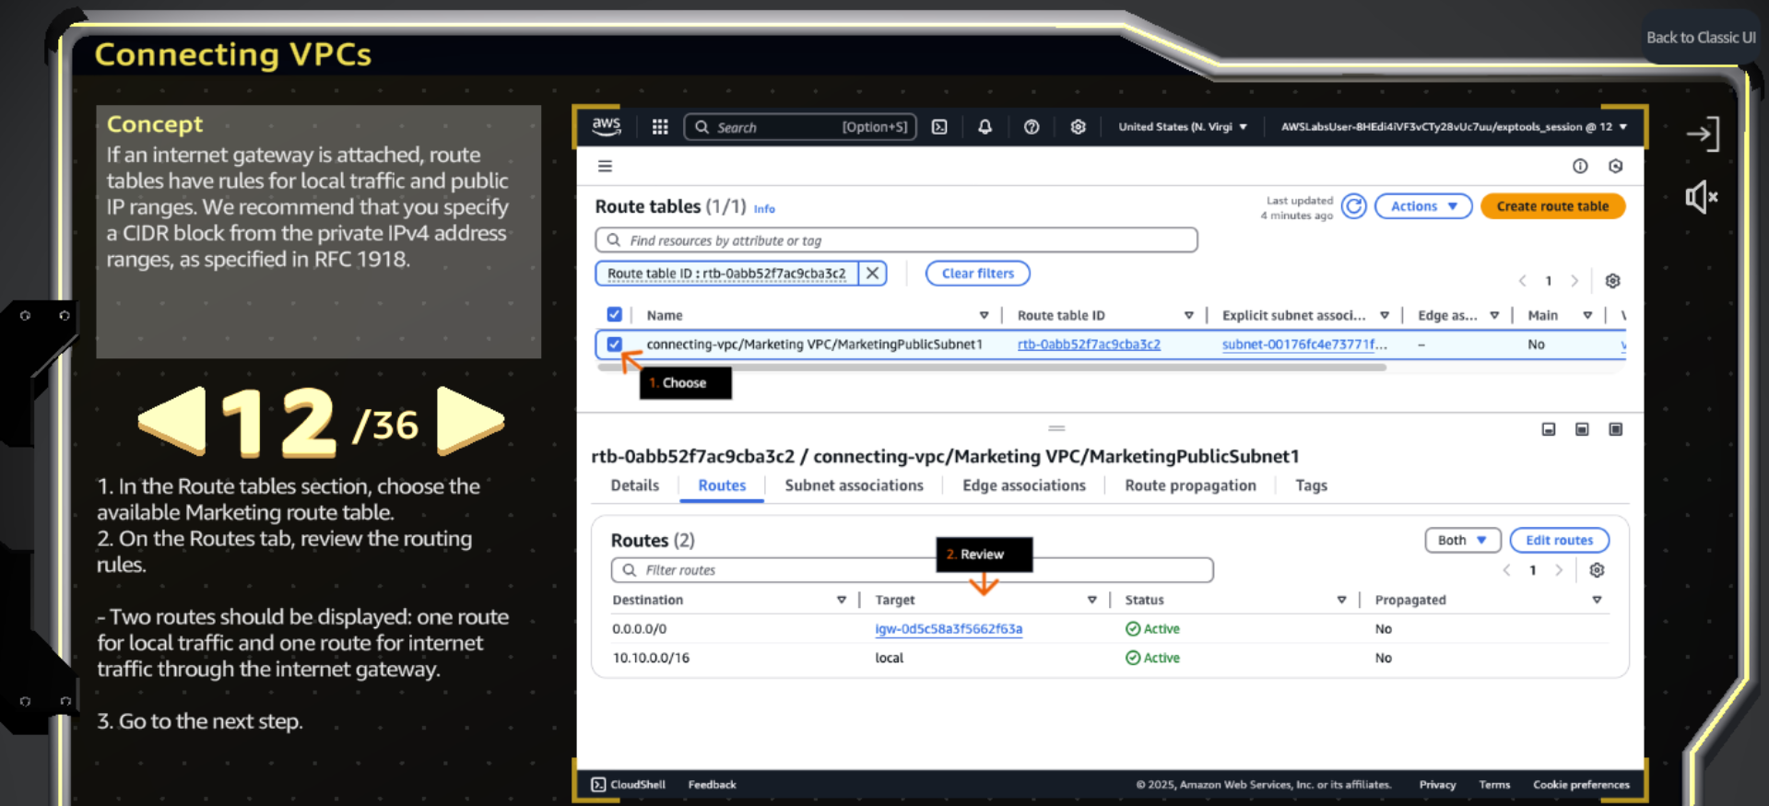

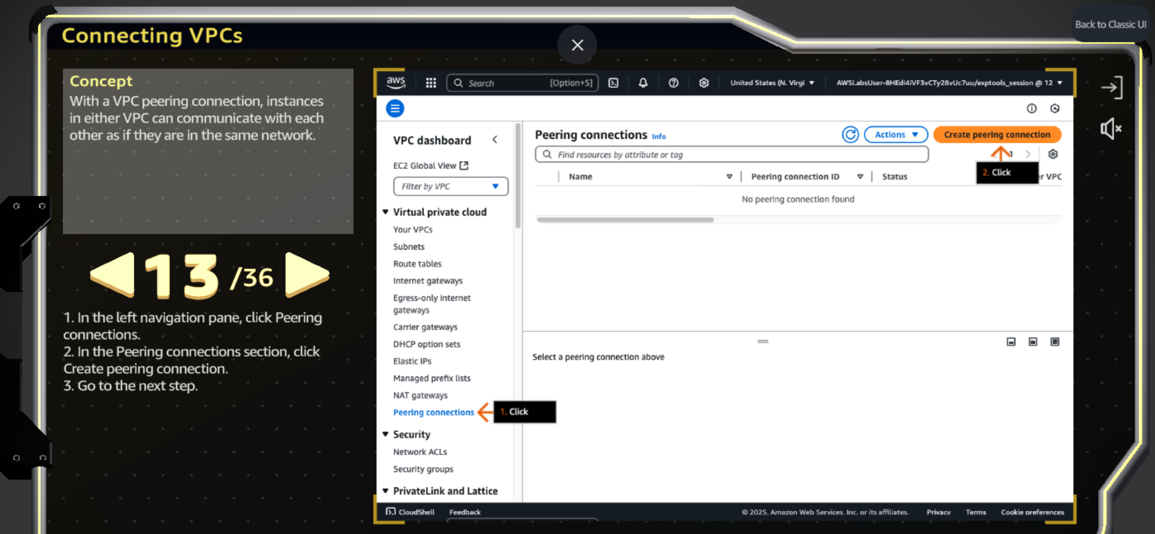

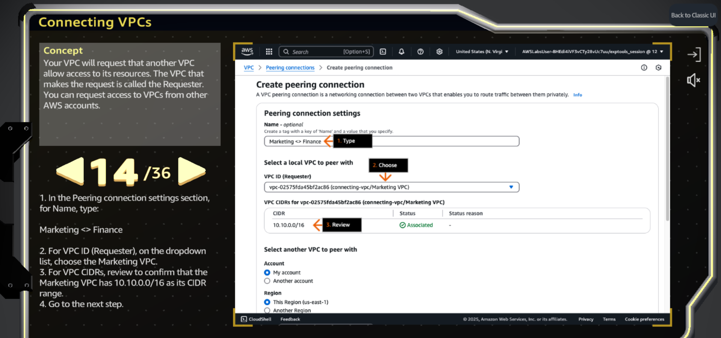

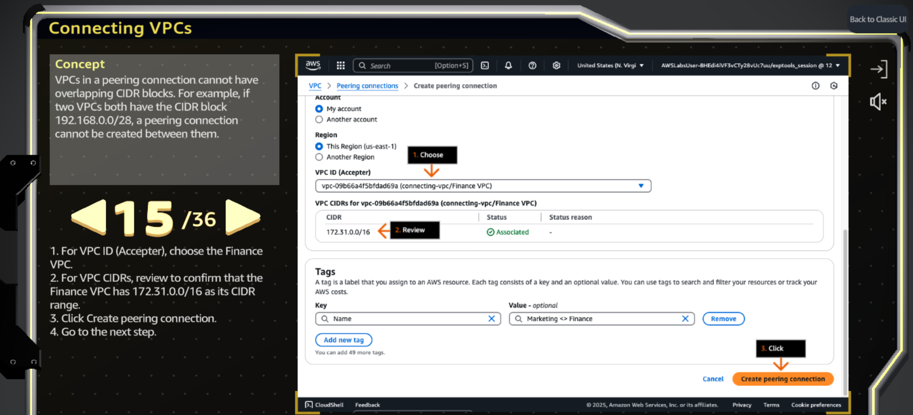

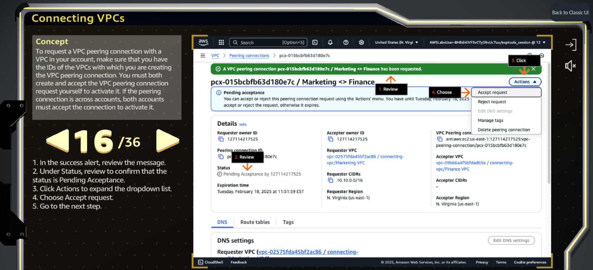

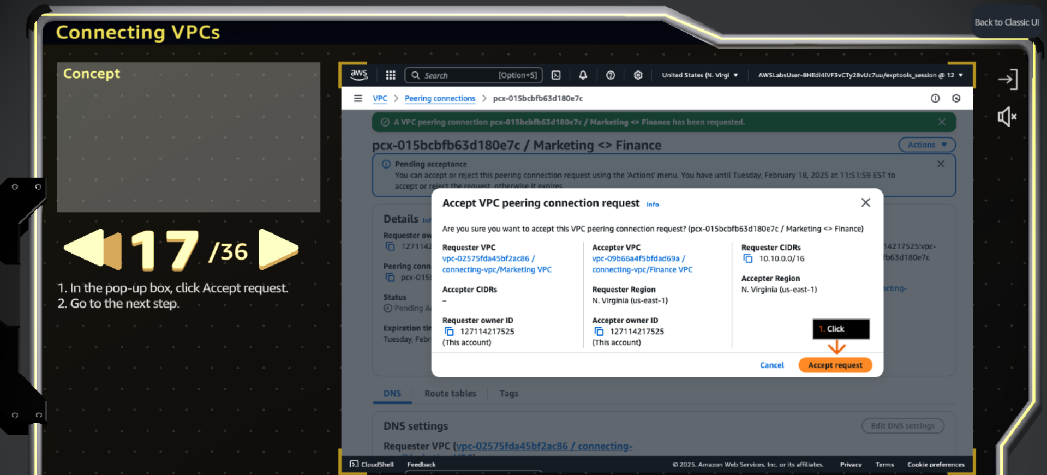

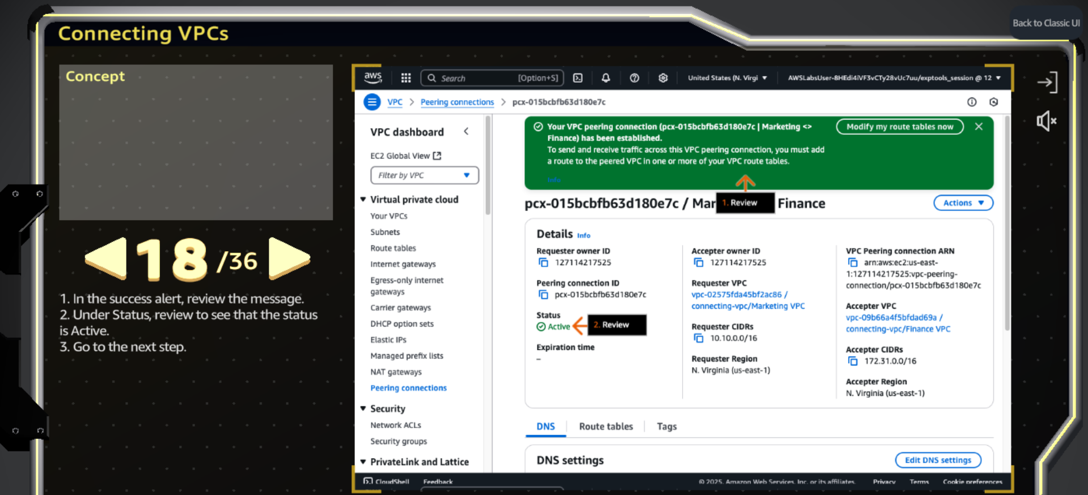

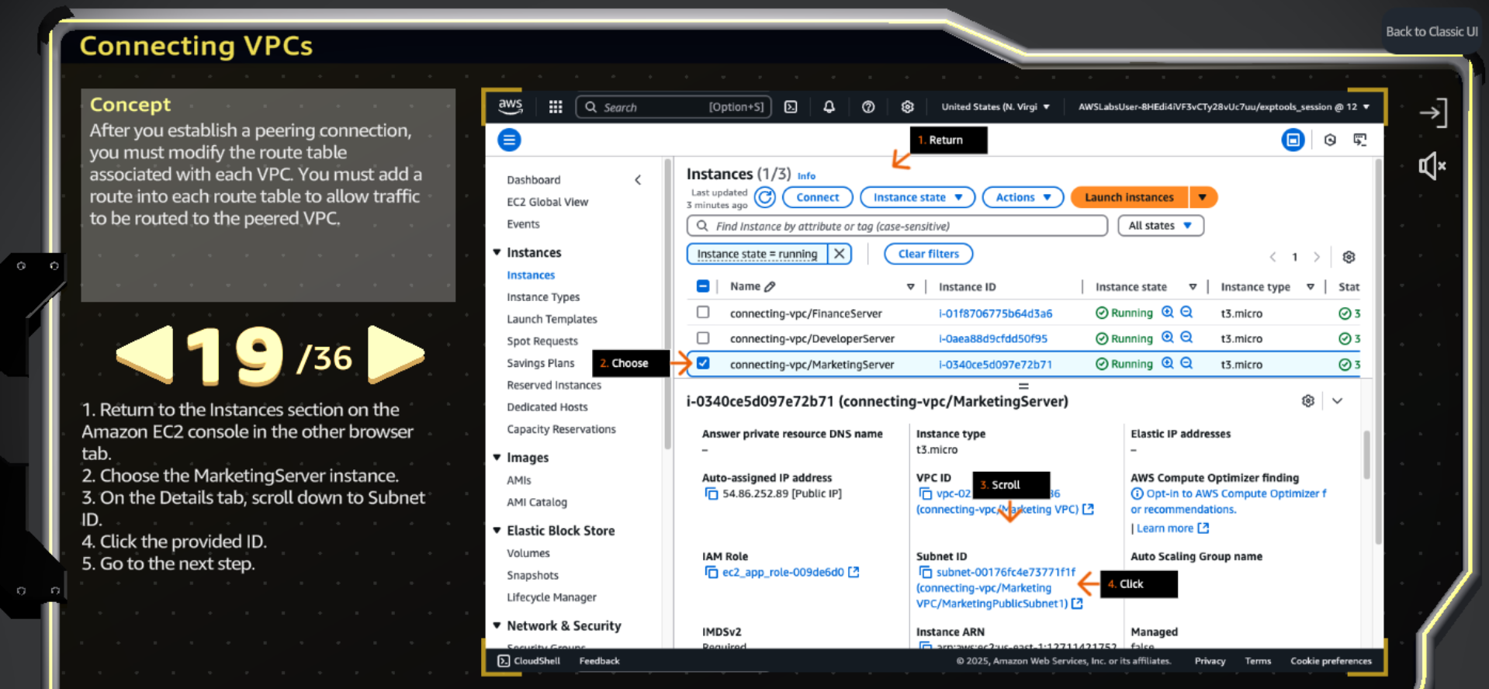

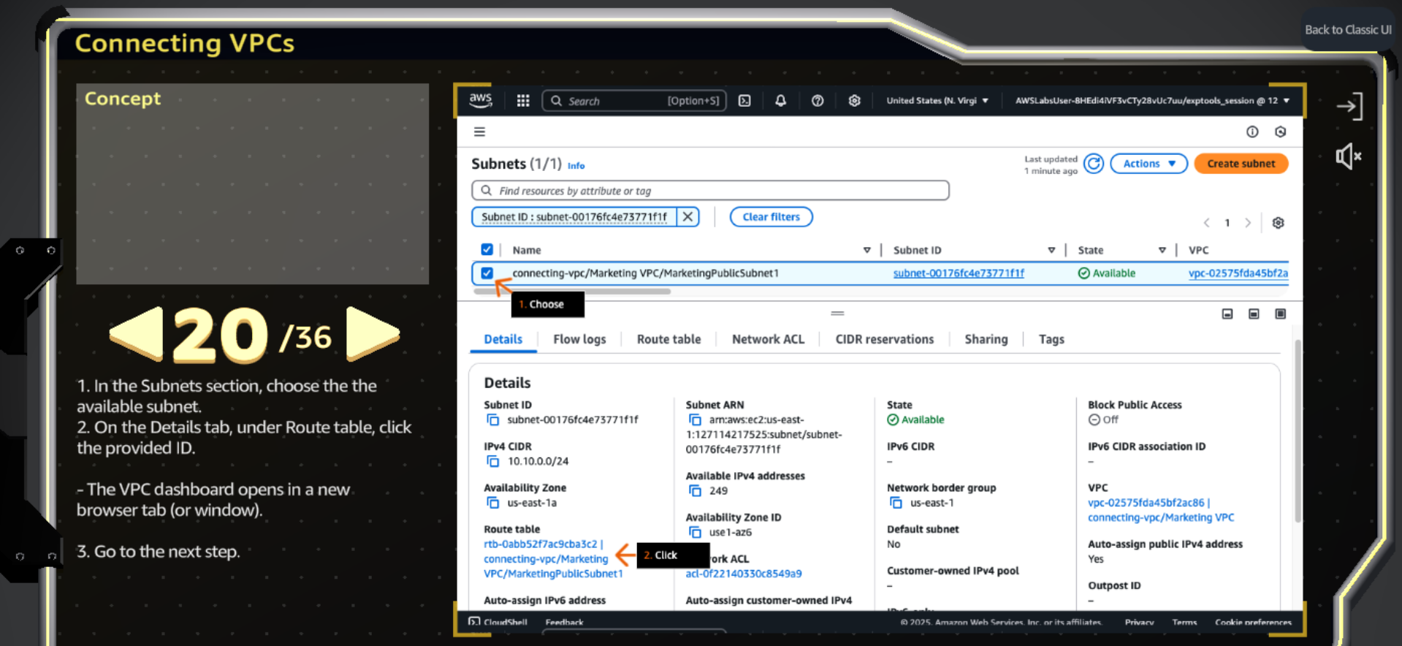

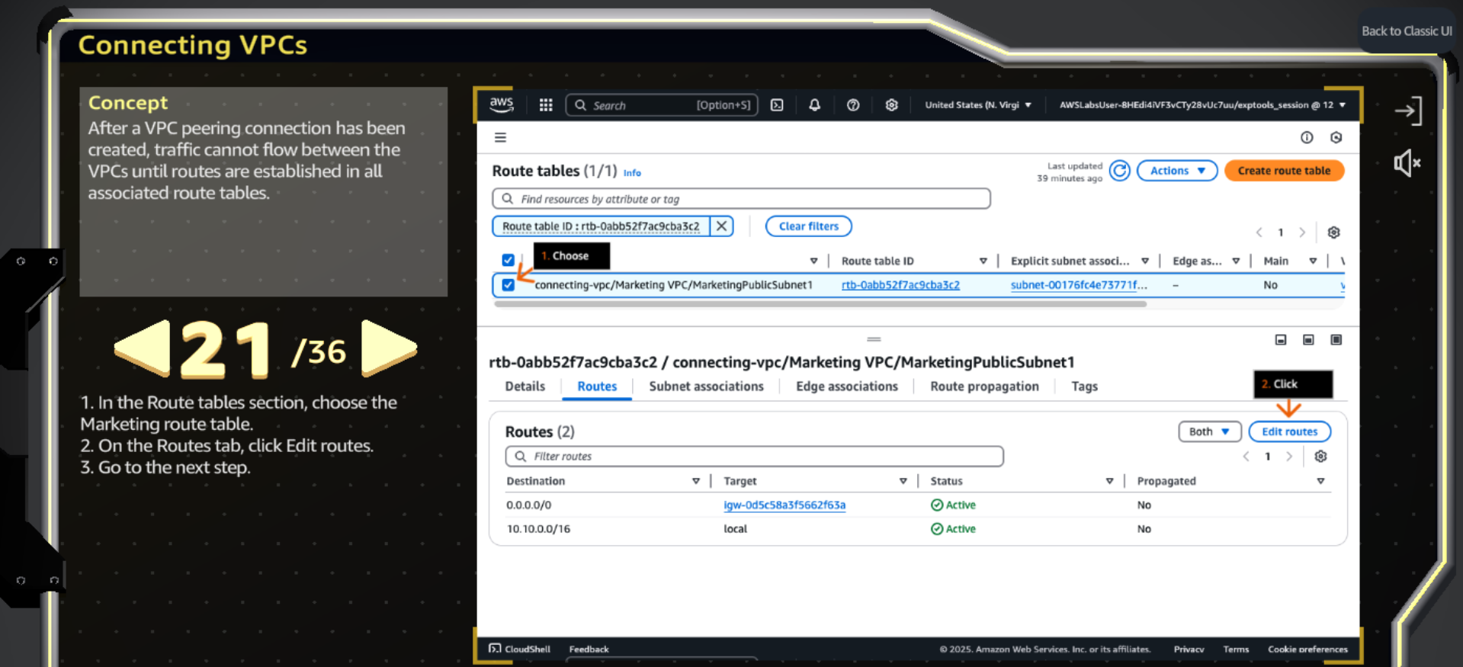

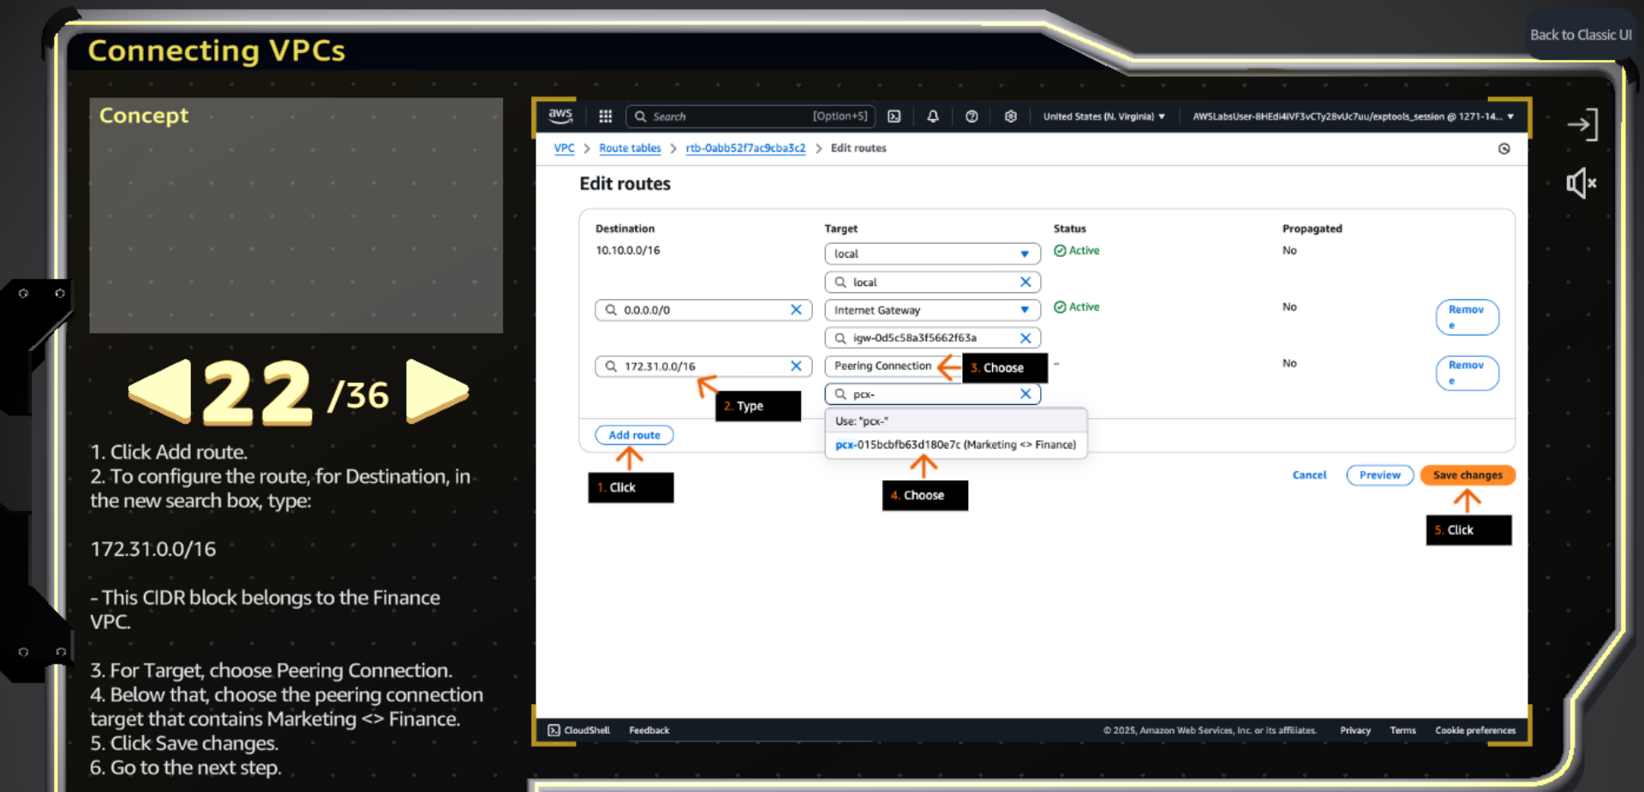

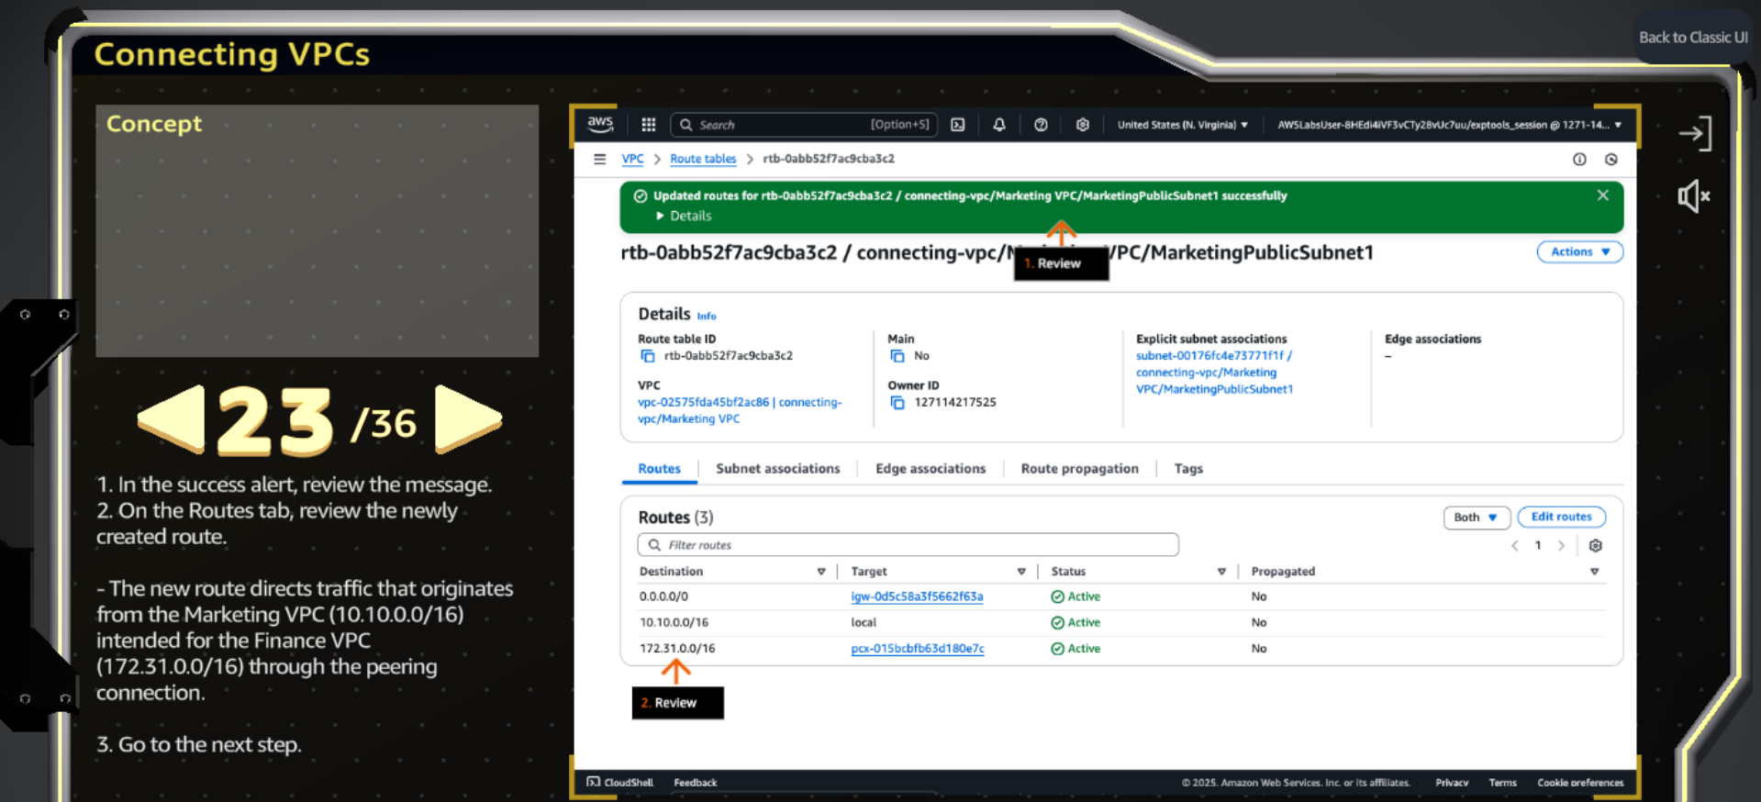

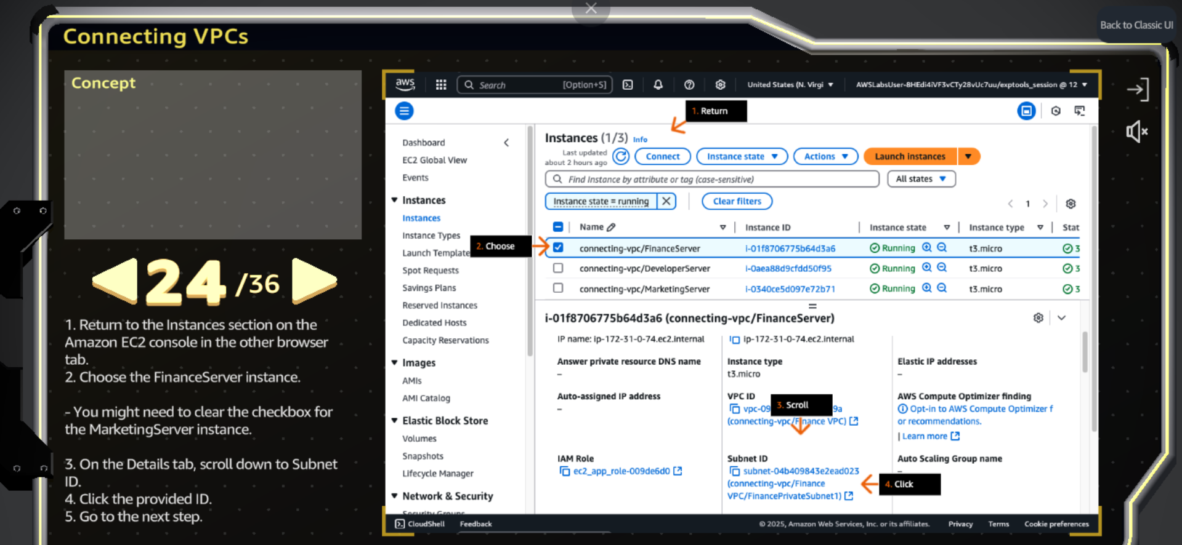

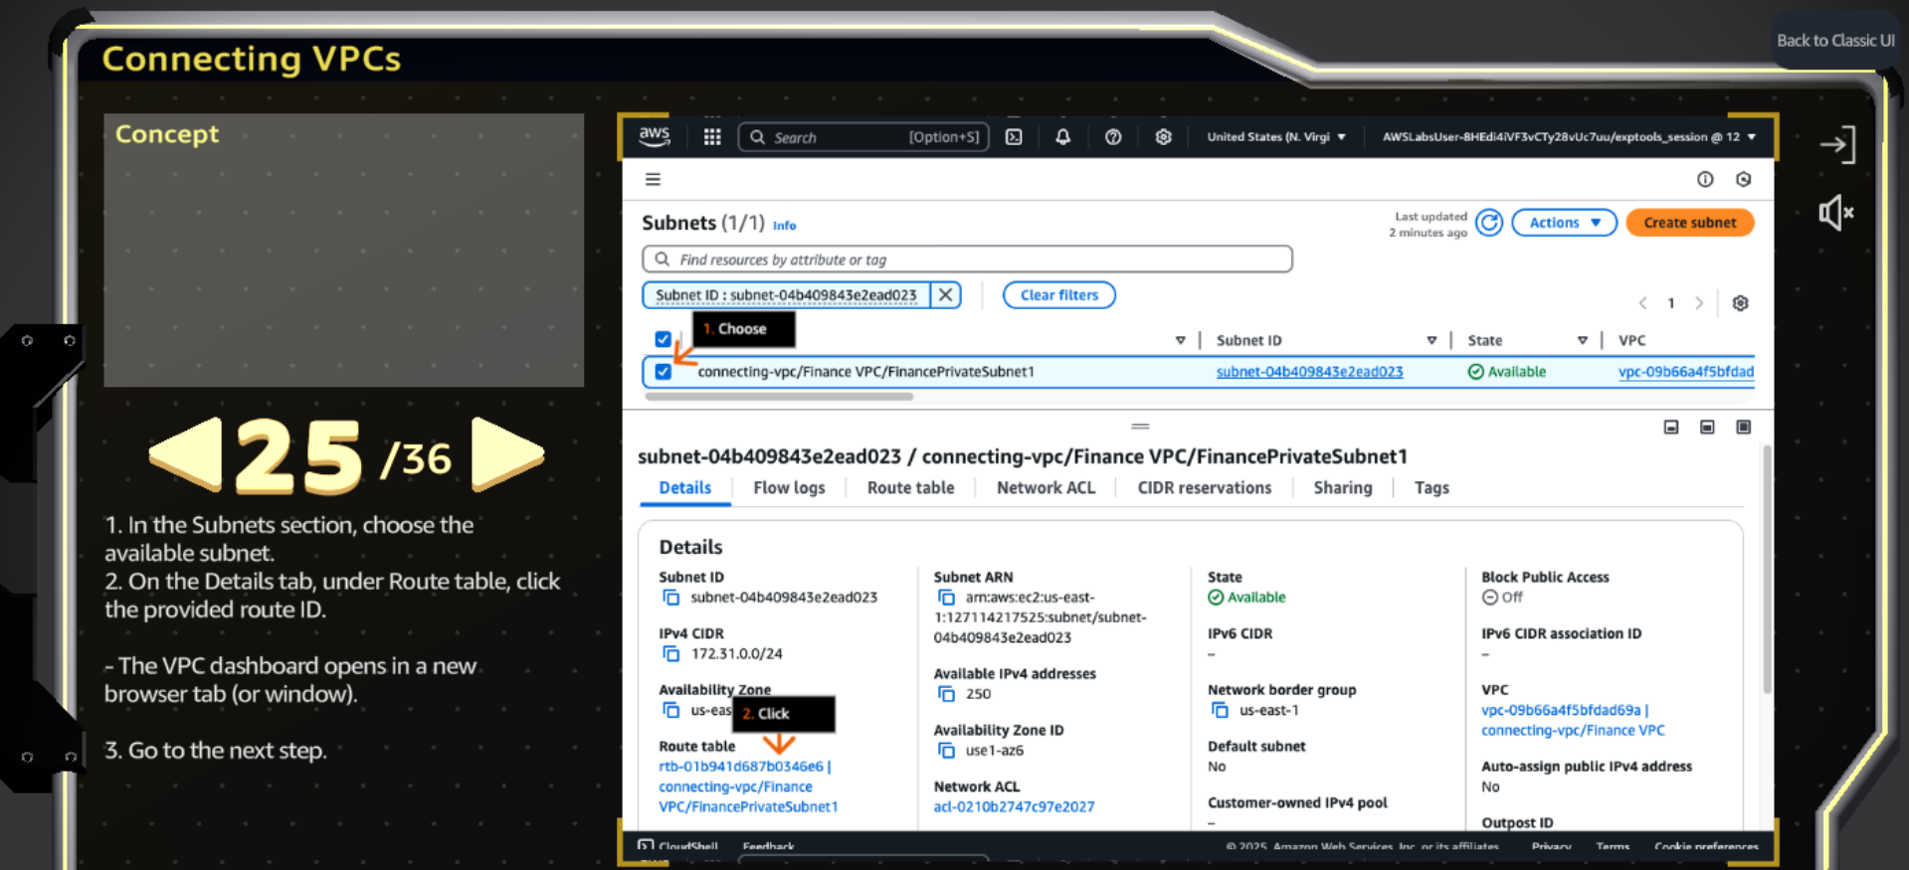

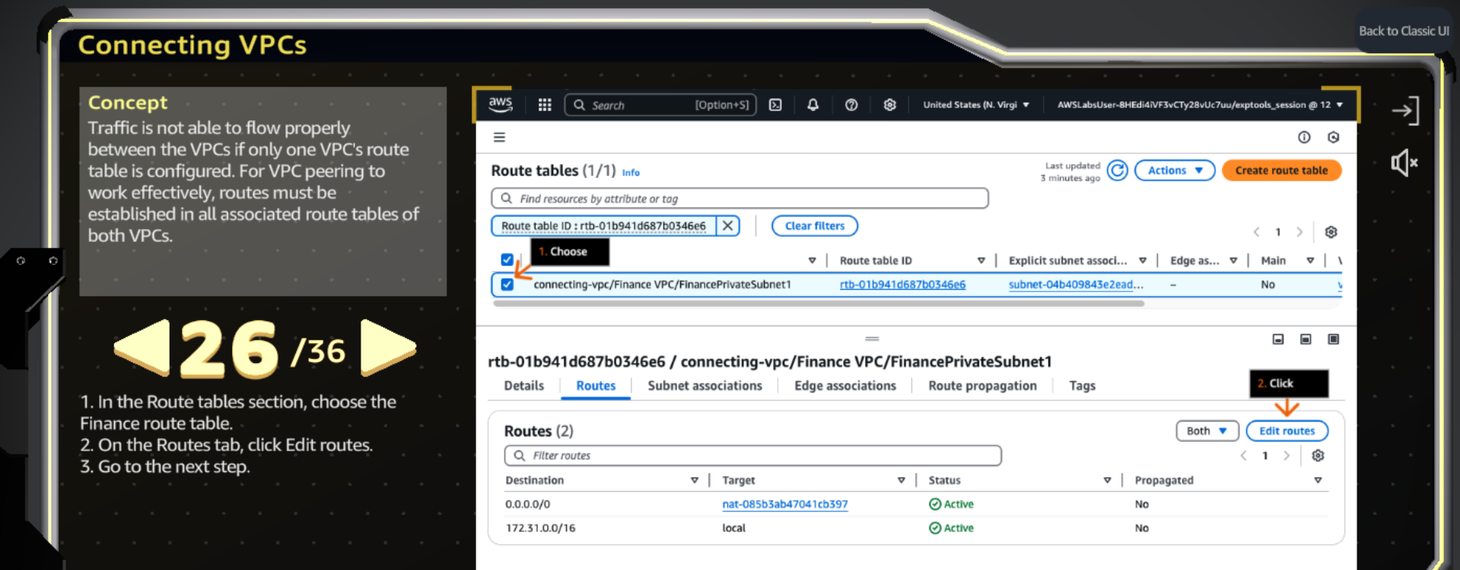

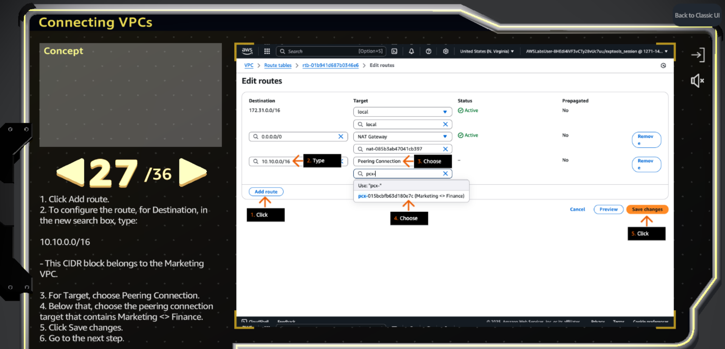

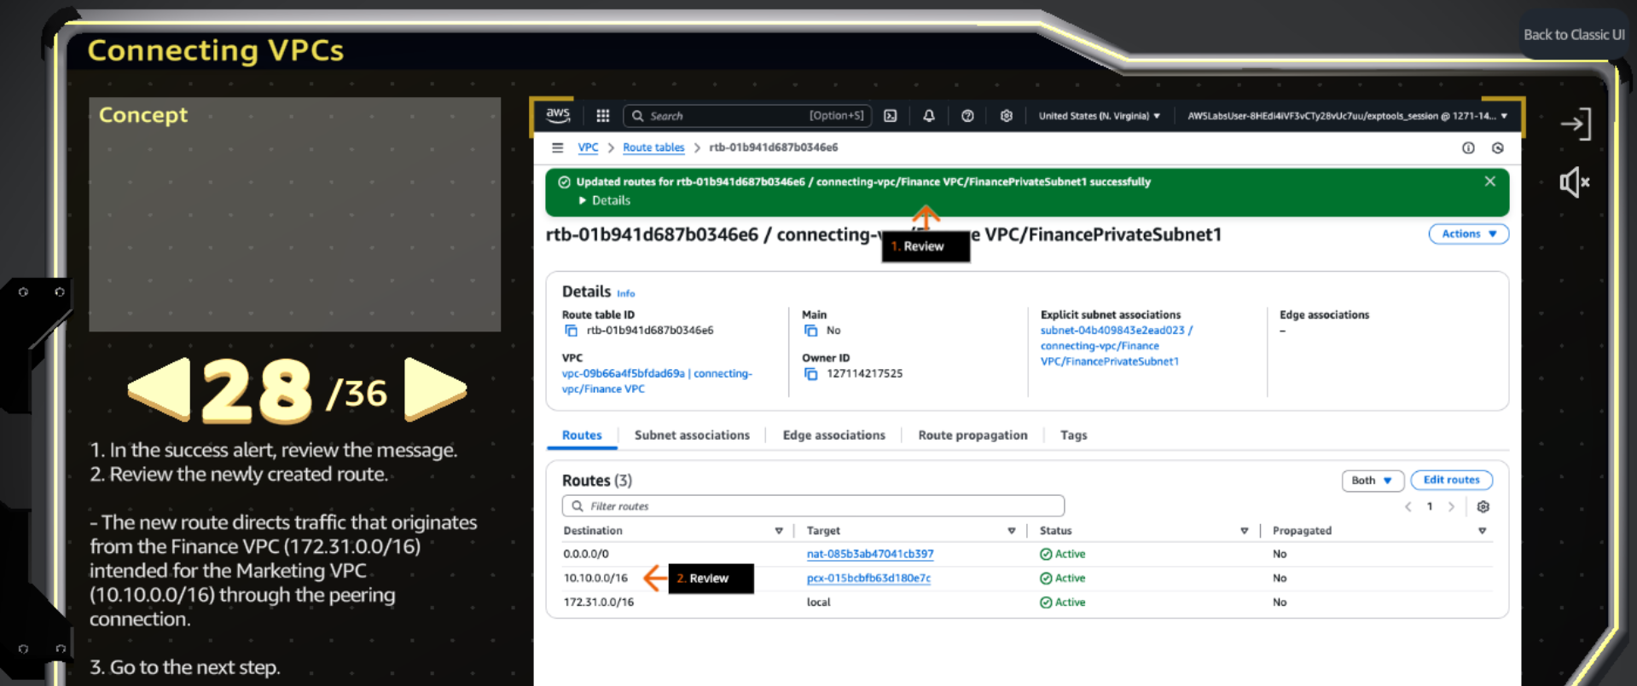

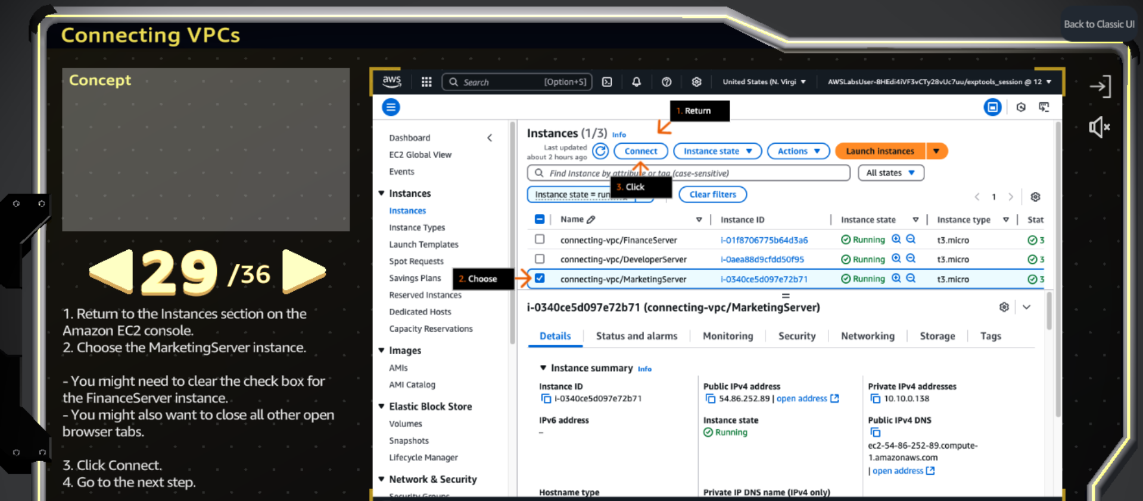

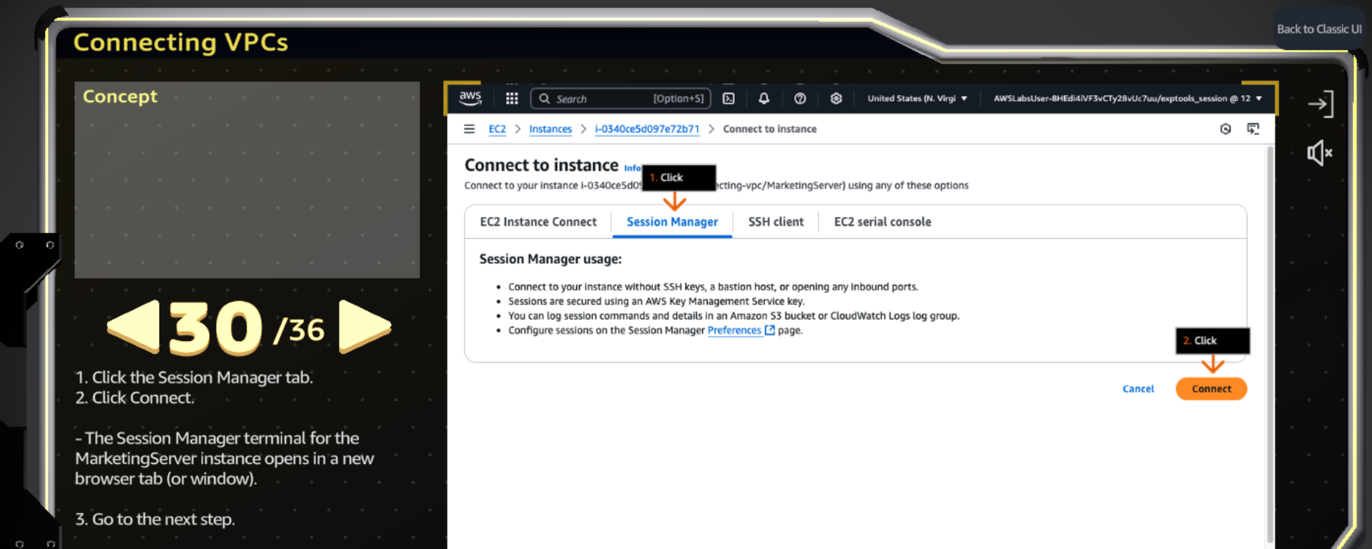

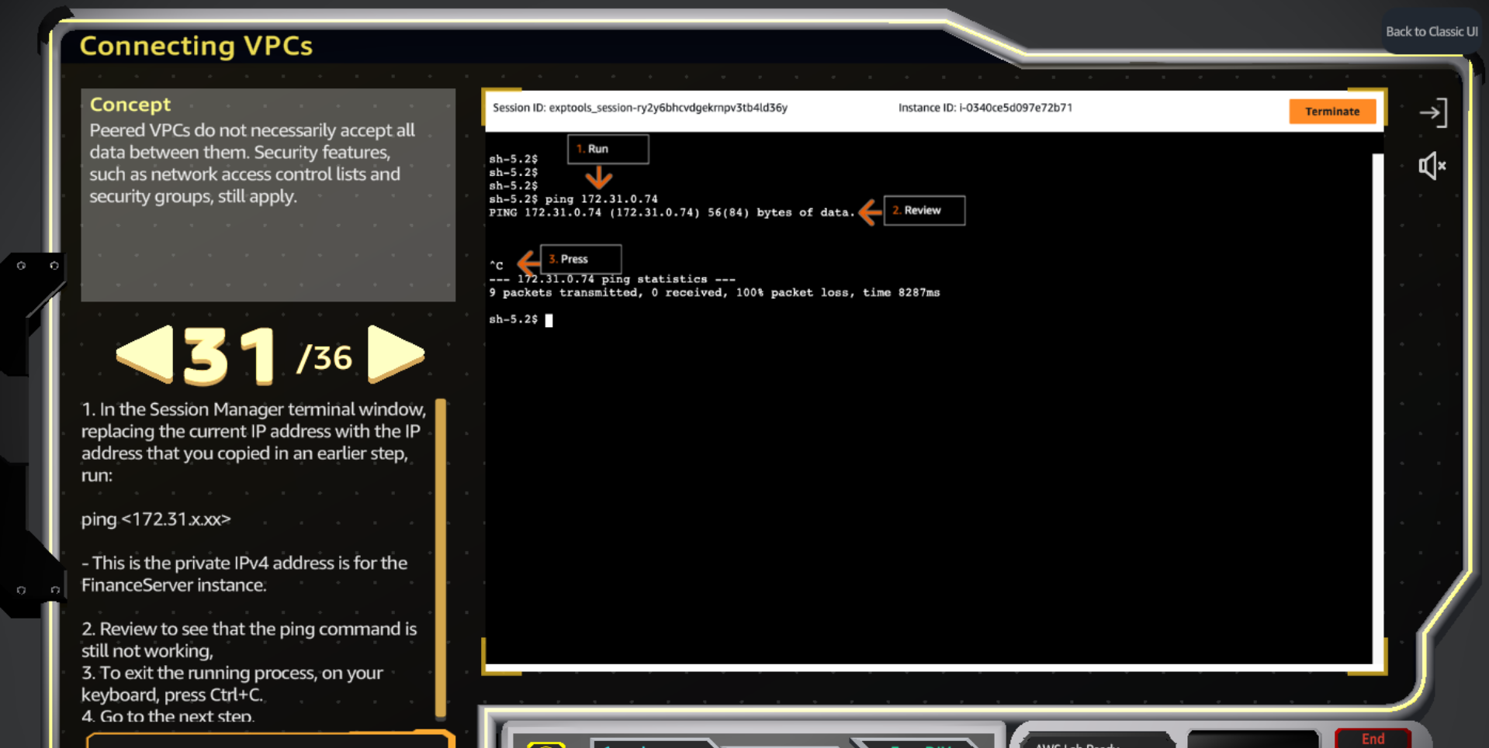

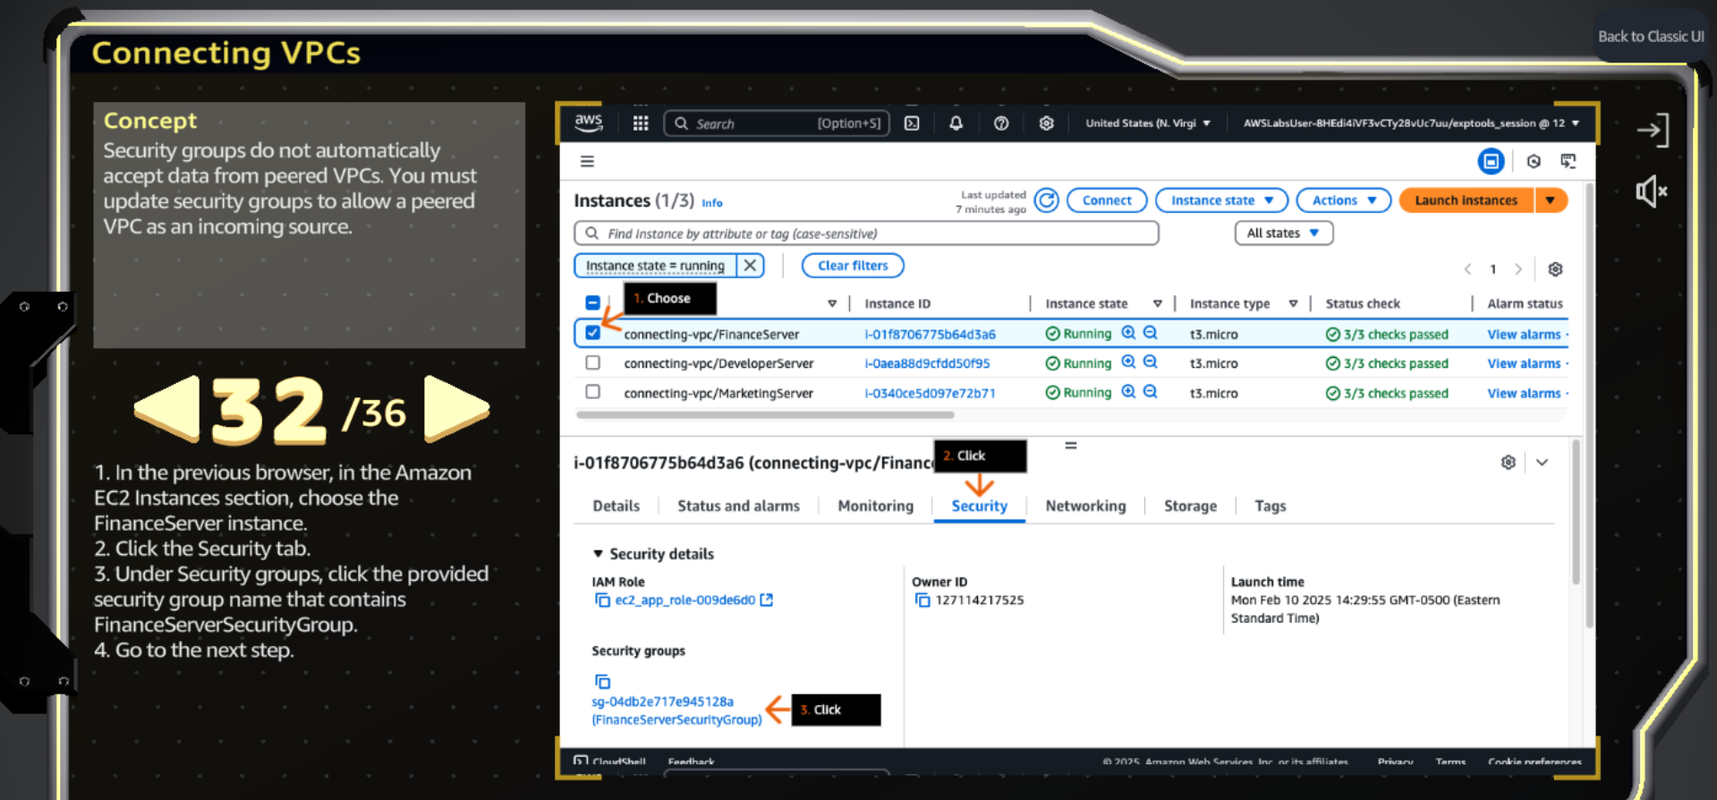

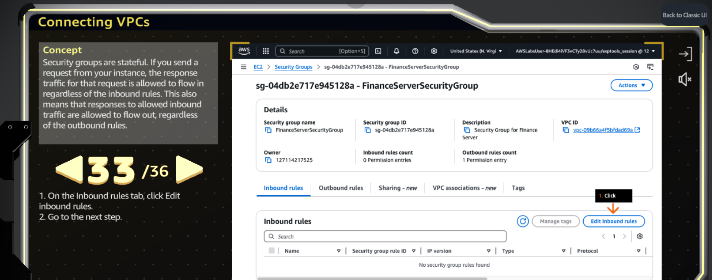

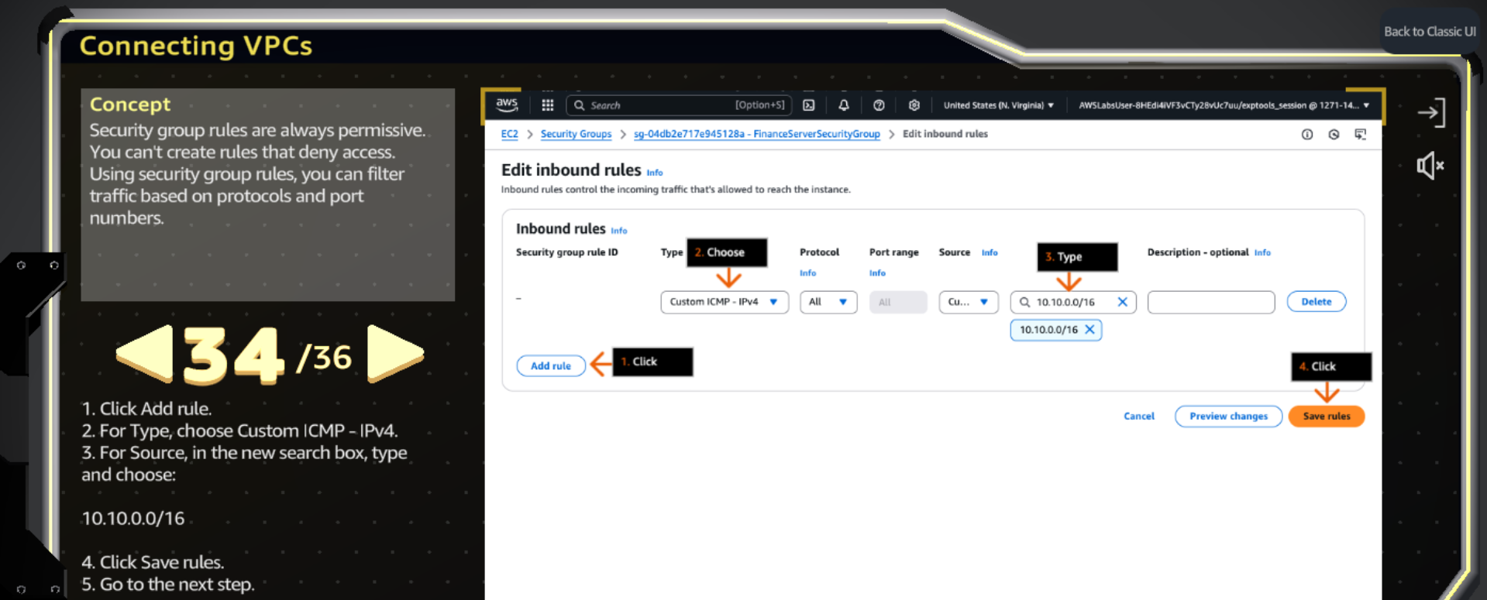

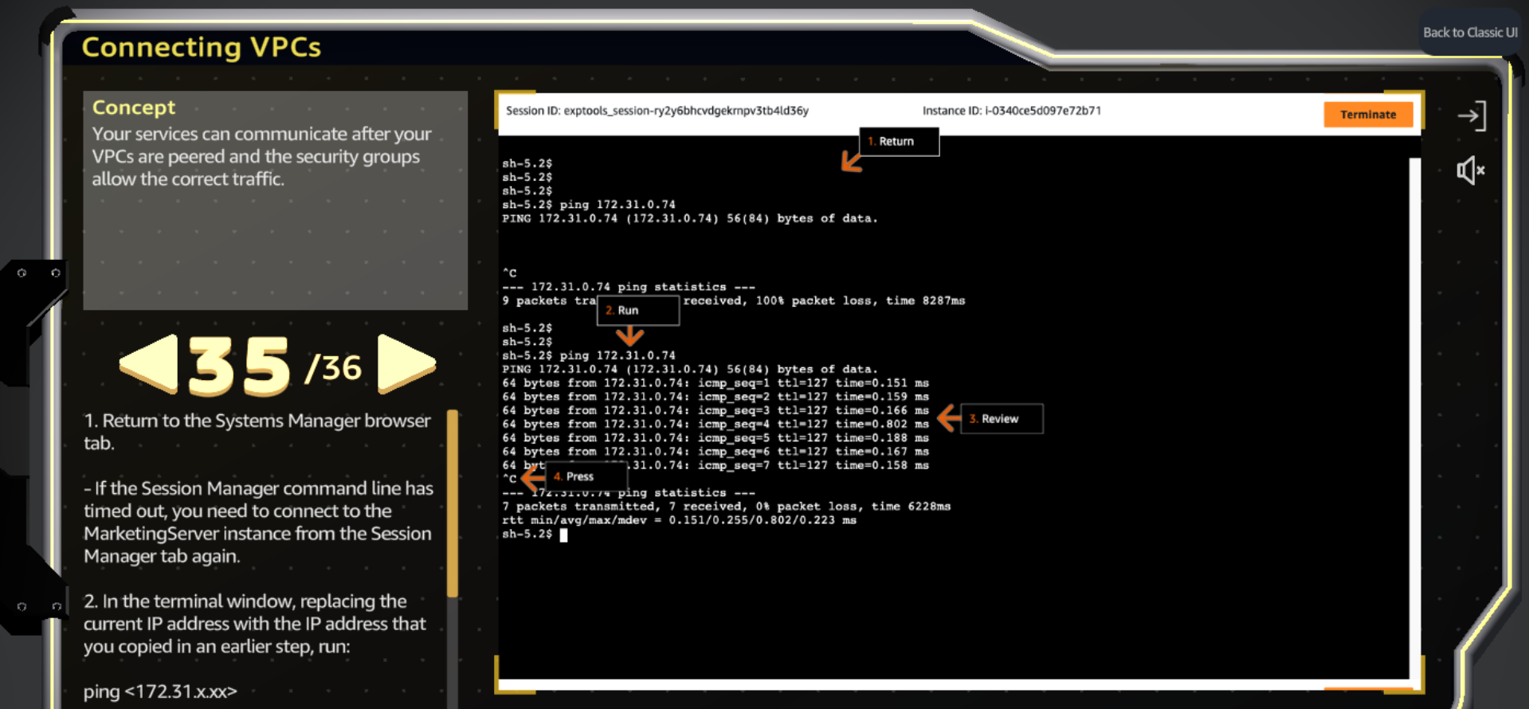

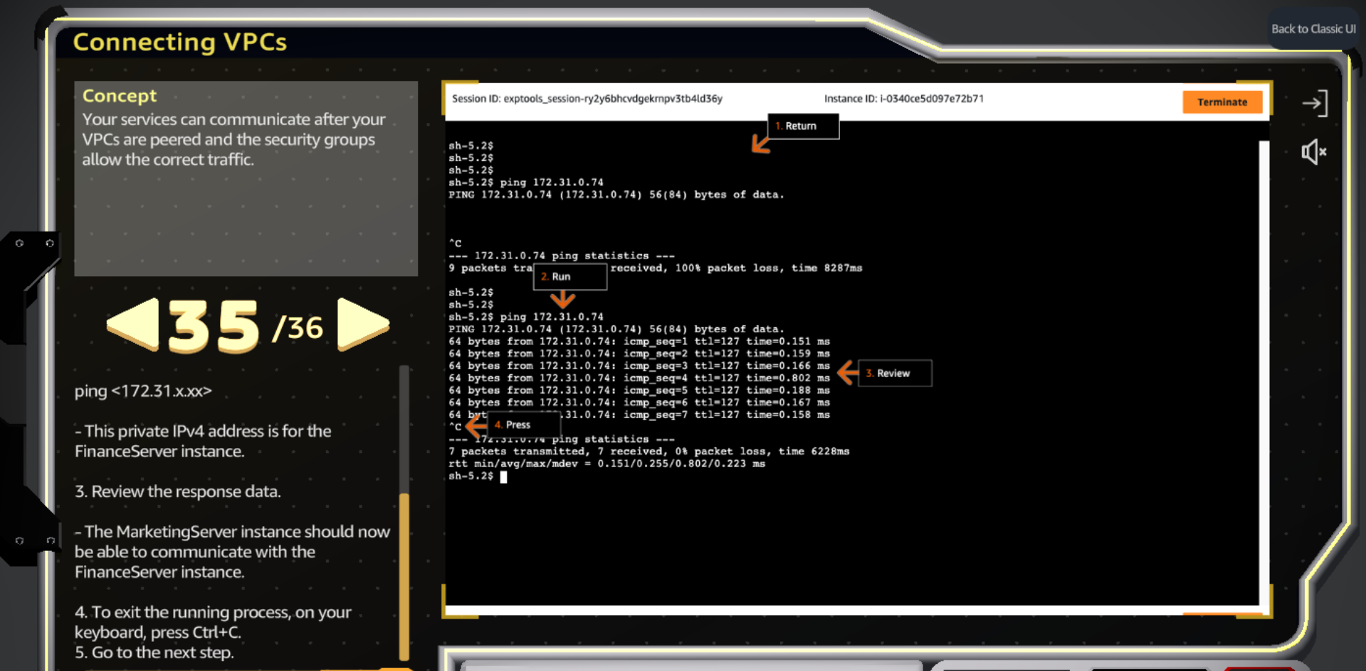

**Step-by-Step: Setting Up VPC Peering Between Two Instances**

1. **Create Separate VPCs for Each Instance**  
   First, make sure each instance is in its own VPC. So, if you have 2 instances, you need 2 VPCs.
2. **Create a Peering Connection**
   * Go to the **VPC Console** → **Peering Connections**
   * Click **Create Peering Connection**
   * Give it a name
   * Select the **Requester’s VPC ID** and the **Accepter’s VPC ID**
   * Click **Create Peering Connection**
3. **Accept the Peering Request**
   * Once created, the status will show as **Pending Acceptance**
   * Select the peering connection → Click on **Actions** → Choose **Accept Request**
4. **Update Route Tables for Both VPCs**
   * Go back to your **instances**, and click on the **subnet ID** of the requester’s instance
   * Open the **Route Table** linked to that subnet
   * Click **Edit Routes**
   * Add a new route:
     + In **Destination**, enter the **Accepter's private IP address or CIDR block**
     + In **Target**, select the **Peering Connection** you just created
   * Do the same steps for the **Accepter’s VPC route table** — add a route to the **Requester’s private IP or CIDR**, and select the **same peering connection** as the target